www.georgialibraries.org/glass
Volume 3, Issue 1 - Fall 2015

BARD for Android has arrived!

At long last, GLASS Android users will be able to use the BARD Mobile app to download books and magazines to their phones or tablets!
Since there is already a version of BARD mobile for devices running iOS -- such as the iPhone, iPad, and iPod touch -- the addition of the Android app means even more GLASS patrons will be able to listen to books and magazines on the device of their choosing.
Patrons with devices running Android OS 4.1 or later can search the Google Play store for BARD Mobile and down- load the free app.
A noteworthy exception is the Kindle Fire. The BARD Mobile app for Android isn’t currently compatible with this de- vice, but this is a work in progress.
For patrons who have newly signed up for and downloaded the BARD app, the user guide is available from the book- shelf of the app.
For BARD mobile how-to videos, check out the Library of Congress’ YouTube playlist at bit.ly/1DHu8ac.
You can also contact GLASS at 1-800-248-6701 for troubleshooting issues or for questions about how to sign up for BARD and other services.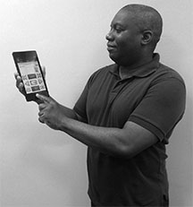

CVI STARS
STARS (Social, Therapeutic, Academic and Recreational Services) is an education- al, recreational, and social skills program for youth in grades K through 12 who are blind or visually impaired. Based out of and operated by the Center for the Visually Impaired in Atlanta, Georgia, STARS signup and most of its events and services are free.
The goal of the STARS program is to provide not just entertainment for school-aged children, but to positively impact students’ social and emotional growth from child- hood through adolescence and into young adulthood. This means guiding students in the development of healthy habits and lifestyle choices, promoting social interaction with peers and positive role models, and increasing community access.
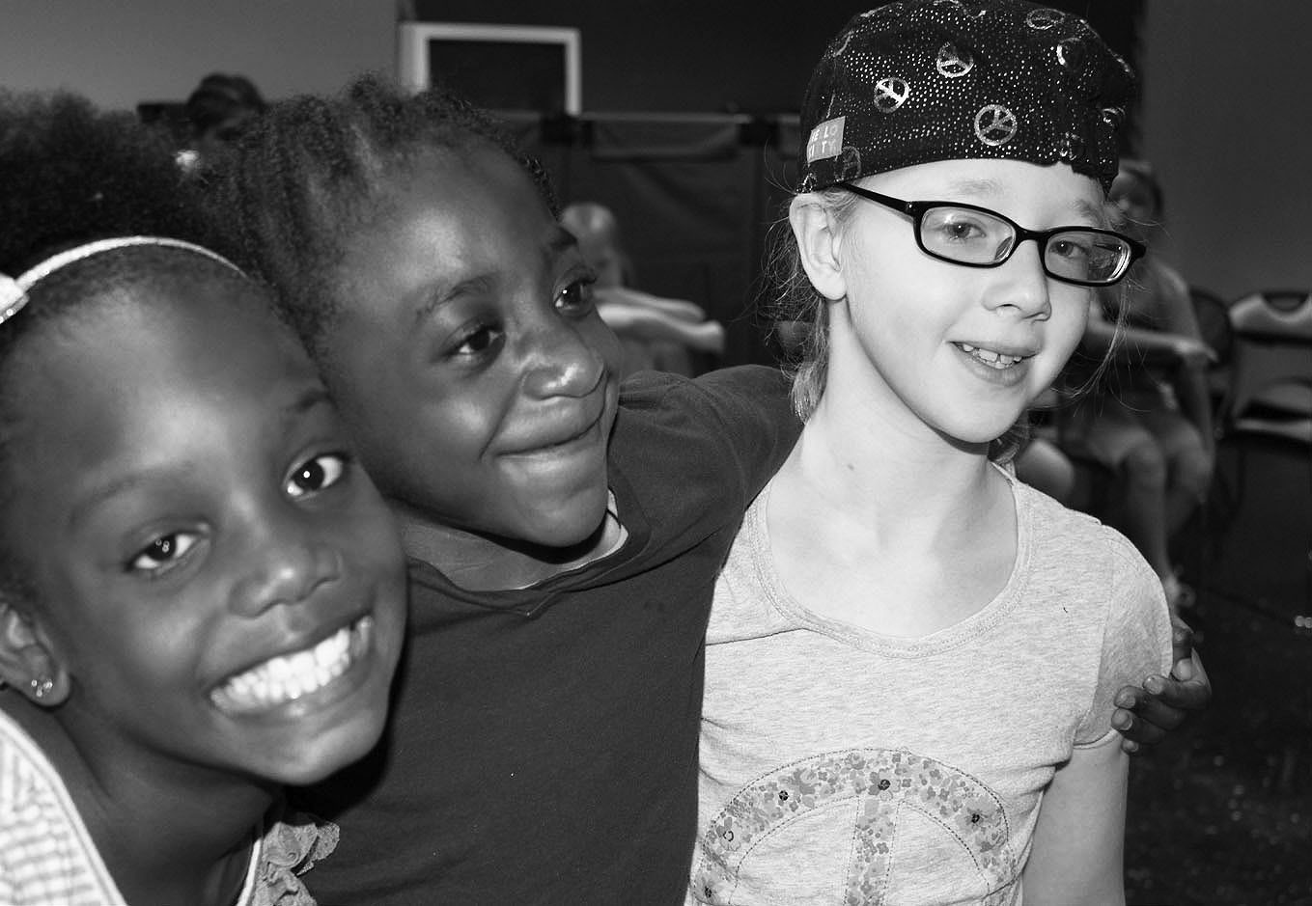
Students acquire independent living, decision-making, and leadership skills, with a particular focus for upcoming high school graduates, who are given the skills, knowledge, and self-confidence necessary to succeed in post-secondary educational and work experiences.
Age-specific programs are provided year round, including summer enrichment day camps, retreats, weekend activities, the mentor pro- gram for youth, and consultation and support for parent-teacher conferences.
To learn more about STARS call 404-602-4368 or email stars@cviga.org for more information.

Super Reads for Young Superheroes

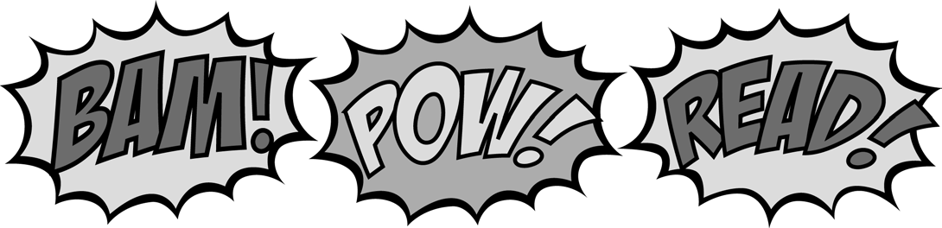
Origin Story Series by Rich Thomas (DB074943)
Seven books explaining how Spider- Man, Thor, Captain America, Iron Man, and the Hulk became legendary super- heroes. For grades K-3.
Diary of a Fly by Doreen Cronin (DB074657)
A young fly describes her sometimes gross but very funny life as she dreams of being a superhero. For grades K-3.
The Adventures of Captain Underpants by Dave Pilkey (DB049974)
Two mischievous fourth graders hypnotize their principal into thinking he’s their comic creation. For grades 2-4.
Frozen: The Junior Novelization by Sarah Nathan (DB078544)
Adapted from the film. Anna tries to res- cue her magical sister so they can save their kingdom. For grades 2-4.
Flora and Ulysses: The Illuminated Adventures (DB080753)
Comic-reading Flora rescues a squirrel with super powers. For grades 3-6.

Athens Patrons Merge with GLASS
After careful consideration regarding how to best serve the talking books patrons of Georgia, the Georgia Public Library Service decided the Athens- based Northeast Georgia Talking Book Center (NEGATBC) would merge with the Georgia Libraries for Accessible Statewide Services (GLASS). On July 1, 2015, all NEGATBC patrons became GLASS patrons.
What this means for NEGATBC patrons is they will receive talking books through GLASS. Service will continue as normal, and patrons do not need to update their information with GLASS, or to otherwise do anything but enjoy the books they are receiving.
The number patrons can call to request items has changed to 1-800-248-6701. The experienced, friendly reader advisors at GLASS are available Monday through Saturday to take requests, provide advisory, and to provide other services.
FREE MATTER FOR THE BLIND AND PHYSICALLY HANDICAPPED
Georgia Libraries for Accessible Statewide Services
1800 Century Place, Suite 150
Atlanta, GA 30345
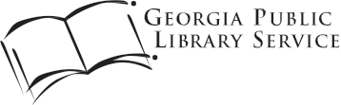

New at NEWSLINE
NFB-NEWSLINE is proud to add The Hill, a national newspaper, to its list of publications. Since its launch in 1994, The Hill has provided nonpartisan information and breaking stories from Capitol Hill, K Street, and the White House.
The Hill joins over 300 publications pro- vided free to eligible users. Call 1-866-504-7300 for more information.
Call 404-235-7157 to request this newsletter in alternate formats. Join our email list at: hourglass@georgialibraries.org

HourGLASS is published quarterly by the Georgia Libraries for Accessible Statewide Services (GLASS), a division of Georgia Public Library Service, a unit of the University System of Georgia.
This publication is made possible by a grant from the U.S. Institute of Museum and Library Services to Georgia Public Library Service under the provisions of the Library Services and Technology Act.
Georgia Libraries for Accessible Statewide Services
1800 Century Place, Suite 150
Atlanta, GA 30345
Phone: 404-235-7200
Toll Free: 1-800-248-6701
Fax: 404-235-7201

www.georgialibraries.org/glass

