www.georgialibraries.org/glass
Volume 3, Issue 3 - Spring 2016

UEB: The New Braille Standard

You may have heard of Unified English Braille (UEB), the new official literary code for the United States. UEB com- bines literary and technical braille while also providing a code that is shared by many English-speaking countries.
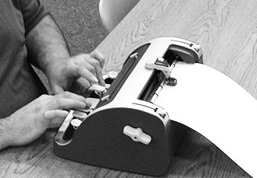UEB is similar to existing literary braille, though it does differ in a few ways. Some rules for the use of contractions will change. Some contractions will be used more often, while nine contractions will no longer be used. Readers can also expect a few punctuation changes, but letters and numbers will remain unchanged from the current literary code.
The transition to UEB took place over several years, and in 2016 implementation began. This means in 2016 devices and software should accurately incorporate UEB, and new transcriptions are released in UEB.
Technical manuals may use either UEB or the existing Nemeth Code. Braille books from the National Library Service (NLS) are now transcribed into UEB, and almost 50 are available in BARD.
Georgia educators begin teaching the code this year as well. The Georgia Department of Education has followed a multiyear plan to ensure that teachers, textbooks and students are ready for the transition.
People who aren’t students also have great resources for learning UEB. GLASS Atlanta has brailled handouts on UEB basics. Call 800-248-6701 to request a copy.
If you’re interested in further study, visit the Hadley School for the Blind online at www.hadley.edu. Their courses are free to users who are blind or visually impaired and their families. Professionals serving individuals who are blind can also receive discounted tuition.

AIRS: Adaptive and Inclusive Sports
Winter’s almost over and with the warmer seasons come outdoor sports! In the Athens area is Athens Inclusive Recreation and Sports (AIRS), which provides sports for people with visual impairments, including beep baseball, beep kickball, golf and kayaking. AIRS also sponsors many more adapted sports including wheelchair basketball and power wheelchair soccer. Even wheelchair tennis is being developed!
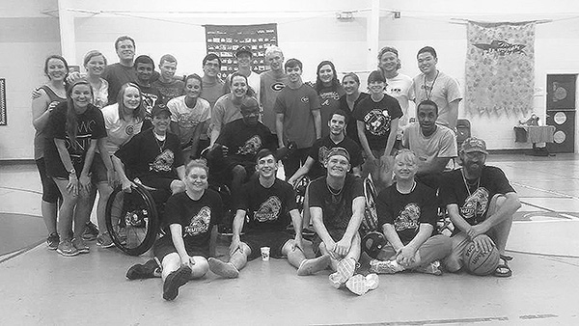AIRS constantly looks to adapt sports for visually impaired athletes. When they first considered a program for kayaking, they were faced with the seemingly impossible task of providing the visually impaired athletes a way to stay on course as they maneuver on the water. Working with an engineer from Bell Labs, AIRS developed a guidance device for kayakers. Now athletes can spend time on the water during summer.
Another recent addition is beep kickball, which can serve as a new athlete’s introduction to beep baseball. Both are placed with beeping bases and balls and use beep baseball rules.
While many participants play sports for fun or to socialize with friends, for others the competition is fierce. The AIRS Timberwolves have competed in the Beep Baseball World Series since 2012.
Finally, AIRS takes the “Inclusive” in their name seriously: Individuals without disabilities are invited to play.
For more information you can call AIRS at 706-353-7463. You can also visit their website at www.airs-ga.org or you can follow them on Facebook at Athens Inclusive Recreation and Sports.
If adaptive sports sound fun but you don’t live near Athens, you can find adaptive sports near you at www.disabledsportsusa.org.

Accessible Technology in Your Library
Georgia Public Library Service (GPLS) has supplied a suite of assistive technology devices to every public library system in the state.
Each public library system received four types of devices including one that reads paper documents aloud. Two devices are magnifiers, one handheld and one that provides magnified output to a computer. Each system was also given enough high- contrast keyboards to provide one to each branch.
Library systems have placed their new technology in branches where they will best serve library patrons. Ask your librarian what is available at your library!

Books To Take You Places

Note: Braille book numbers begin with BR, while talking books begin with DB.

The Wild Places by Robert Macfarlane (DB69068)
Macfarlane recounts his journeys in search of the remaining “wild places” in England, Ireland, Scotland and Wales.

Around the World in 50 Years: My Adventure to Every Country on Earth by Albert Podell (DB81883)
Beginning with his trip to Canada in 1962, Podell describes his travels to every country on Earth, including seven that no longer exist. Describes personal relationships with his family and girl- friends, co-leading the Trans World Re- cord Expedition, and ways he entered countries closed to tourists.

Grandma Gatewood’s Walk: The Inspiring Story of the Woman Who Saved the Appalachian Trail by Ben Montgomery (DB80502)
Biography of Emma Gatewood, who left her family in May 1955, saying only that she was going for a walk. Four months later she completed a solo hike of the Appalachian Trail, from south to north -- the first woman to do so.

A Sense of the World: How a Blind Man Became History’s Greatest Traveler by Jason Roberts (BR16660, DB62703)
Biography of Englishman James Holman (1786-1857), who was blinded at 25 after serving in the Napoleonic wars and who then achieved fame as a world traveler.
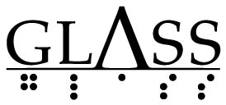
Georgia Libraries for Accessible Statewide Services
1800 Century Place, Suite 150
Atlanta, GA 30345

Librarian Resource
Librarians: Where do you go when someone asks you about GLASS?
The GLASS webpage is an excellent resource, particularly the “Resources for Librarians” page. This page is curated especially for you, with a section on the accessible technology from Georgia Public Library Service. Check us out at www.georgialibraries.org/glass.
Call 404-235-7157 to request this newsletter in alternate formats. Join our email list at: hourglass@georgialibraries.org

HourGLASS is published quarterly by the Georgia Libraries for Accessible Statewide Services (GLASS), a division of Georgia Public Library Service, a unit of the University System of Georgia.
This publication is made possible by a grant from the U.S. Institute of Museum and Library Services to Georgia Public Library Service under the provisions of the Library Services and Technology Act.
Georgia Libraries for Accessible Statewide Services
1800 Century Place, Suite 150
Atlanta, GA 30345
Phone: 404-235-7200
Toll Free: 1-800-248-6701
Fax: 404-235-7201 www.georgialibraries.org/glass

