  - www.georgialibraries.org/glass
  - Volume 3, Issue 4 - Summer 2016

On Your Mark: Summer Reading Program

On your mark, get set ... READ!
Public libraries all over the state of Georgia are preparing summer reading programs for children in their communities. Likewise, GLASS is preparing the 2016 summer reading activities for our young readers. The program will run from June 1 to July 30.
This is the third year that GLASS has offered a summer reading program where we encourage students to read every day of their summer vacation.
This year’s theme is wellness, fitness and sports. Look for the “Summer Reading List” link on the GLASS web- site for a page with suggested sports- related titles that you can request.
The goal is to have students read a minimum of 10 books to be eligible for a grand prize drawing.
Students may read large print or braille or listen to audio books. Being read to also counts.
If you’re in the Atlanta area, stop by the Atlanta-Fulton Public Library’s Central Library, which is hosting some GLASS Atlanta activities. The GLASS summer reading program kick-off is on June 1 at 11 a.m. On July 12 at 10:30 a.m. is Dramatic Story Time. For older kids and adults is the GLASS Got Talent Variety Show on June 8 at 2 p.m. All are in the auditorium and are free programs.
School-age GLASS patrons can expect their packets in the mail inviting them to sign up for the GLASS summer reading program. Call 800-248-6701 if you have any questions, or to reserve books to get you to your goal.

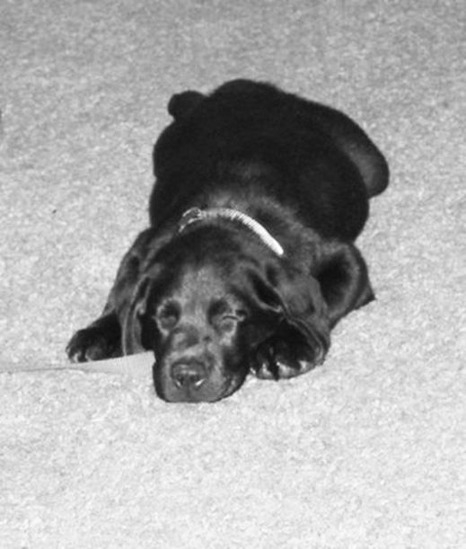Service Animals: From Pup To Companion

When we hear the term “service animals,” we often think of guide dogs for the blind and visually impaired. One thing that many people fail to consider is the training of the guide dog.
Guide dogs are trained to lead their handler safely from one place to another and to adapt to changes in the physical environment.
Socialization and training for guide dogs can begin as soon as a puppy is 8 weeks old. Many puppies are placed with a puppy raiser who focuses on house and obedience training for the puppy. Another big part of their training is being exposed to many potential situations and environments such as businesses, stores, doctor’s offices and mass transit stations. Doing this creates a sense of normalcy for the animal.
Since service dogs are working, it’s extremely important to not distract the dog and just go about your normal day- to-day routine. This includes interactions with the handler and dog. When encountering a dog, most people want to engage with the animal. However, it is important to ask for the handler’s per- mission before petting the guide dog.
When it is around 13 to 15 months old, the dog usually leaves the raiser and returns to the training facility to “graduate” and to be matched with a handler. After this is done, they are off to begin their new lives as guide dogs.
For books about service animals and those who raise them, check out “Two Plus Four Equals One: Celebrating the Partnership of People with Disabilities and Their Assistance Dogs” (DB74137). Another good book is “To the Rescue: Found Dogs with a Mission” (BR18838/ DB70466), which profiles 52 rescue dogs and cats that were trained to be therapy and service animals.

Technology Tips: Easier Appointments
Tired of putting appointments into your calendar? If you have an Apple device with Siri, you can make your smartphone do it for you.
Start by waking up Siri. You can say “Hey Siri” if that feature is on. If it isn’t, press and hold the home button to speak to Siri. Say “Make doctor’s appointment.” Siri will then ask when your appointment is. Say the date and time. She’ll let you know if this event conflicts with anything on your calendar. Confirm the event, and you’re done!

Stay in Suspense with Intriguing Books

Note: Braille book numbers begin with BR, while talking books begin with DB.

Scandalous Behavior by Stuart Woods (DB83540)
Stone Barrington has just landed in England for a vacation, when he’s beset by an outrageous demand from a beautiful lady and an offer he can’t refuse. Unrated.

The Girl on the Train by Paula Hawkins (DB80635)
Rachel’s daily train commute by her old home is very familiar. But one day she sees something she can’t ignore and finds herself tangled in the lives of two other untrustworthy women. Unrated.

Rogue Lawyer by John Grisham (BR21266, DB82636)
Attorney Sebastian Rudd works out of a bulletproof van, defending people other lawyers won’t go near. Unrated.

Private Paris by James Patterson et al. (DB83616)
Jack Morgan tracks down a young woman on the run from a brutal drug dealer. Before Jack can locate her, however, several members of France’s cultural elite are found murdered in stunning, symbolic fashion. Unrated.

Pretty Girls by Karen Slaughter (BR21211, DB82937)
After the brutal murder of her husband, Claire and her estranged sister Lydia band together to uncover the truth. Violence, strong language, and some explicit descriptions of sex.

Breakdown by Jonathan Kellerman (DB83585)
Alex Delaware and LAPD Lieutenant Milo Sturgis investigate the death of actress Zelda Chase and the disappearance of her child Otis, who Alex once evaluated. Unrated.

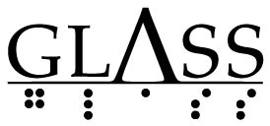
Georgia Libraries for Accessible Statewide Services
1800 Century Place, Suite 150
Atlanta, GA 30345

Missing Magazines?
Be sure to return your magazines as soon as you’re finished so they keep coming in a timely manner! As of April, 58 percent of GLASS patrons aren’t receiving their magazines due to delinquent cartridges. Your issues will stop coming if the cartridges aren’t returned.
If you’ve lost a magazine, call your reader advisor to let them know.
Call 404-235-7157 to request this newsletter in alternate formats. Join our email list at: hourglass@georgialibraries.org

HourGLASS is published quarterly by the Georgia Libraries for Accessible Statewide Services (GLASS), a division of Georgia Public Library Service, a unit of the University System of Georgia.
This publication is made possible by a grant from the U.S. Institute of Museum and Library Services to Georgia Public Library Service under the provisions of the Library Services and Technology Act.
Georgia Libraries for Accessible Statewide Services
1800 Century Place, Suite 150
Atlanta, GA 30345
Phone: 404-235-7200
Toll Free: 1-800-248-6701
Fax: 404-235-7201
www.georgialibraries.org/glass

