# Hourglass logo Our and GLASS are accentuated

[**georgialibraries.org/glass**](georgialibraries.org/glass) **Volume 5, Issue 1 - Winter 2017**

## GLASS RSVP, Your Resource Connection

Looking for programs and resources that serve people in Georgia who are blind, visually impaired or who have other print impairments has just gotten a whole lot easier!

Responding to a mandate established by a House of Representatives Study committee during the 2015-2016 legislative session, the Georgia Libraries for Accessible Statewide Services (GLASS) created a convenient website directory of agencies that serve people who have print impairments. 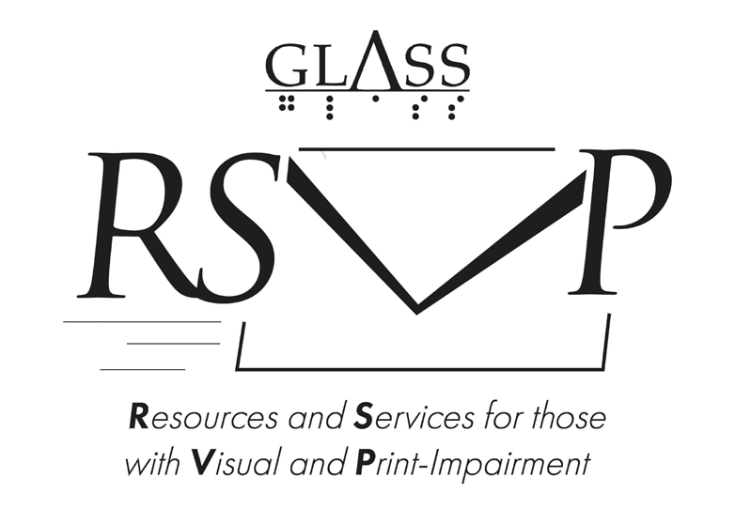

The website is called GLASS RSVP - Resources and Services for those with Visual and Print-Impairment. Users can search the directory by several categories of agencies including: assistive technology, recreational reading, health or career. Links and contact information are given for each resource.

You can find GLASS RSVP by visiting glassrsvp.georgialibraries.org or by going to the GLASS web page at georgialibraries.org/glass and selecting the GLASS RSVP link.

GLASS RSVP will be maintained and updated with additional resources as we become aware of them. Suggested resources that are targeted toward persons with print impairments may be added to the list if deemed an appropriate fit.

Need to browse resources for students or children? Need to find social services specific to visually or print-impaired individuals? Head over to GLASS RSVP and have a look ... you have a standing invitation!

## Project Independence

Are you or someone you know at least 55 years of age and experiencing vision loss or a combined vision and hearing loss? Project Independence could help.

This vision program for adults age 55 and over (also referred to as the Older Blind Program) is administered by the Georgia Vocational Rehabilitation Agency (GVRA). GVRA contracts with six Project Independence service providers across the state to provide services. These services may help you remain independent so you can keep on doing what you like to do.

Services may include:

* Skills training in your home community by certified rehabilitation specialists so you can keep on doing the daily tasks you like and stay active
* Comprehensive low vision evaluations by qualified professionals to assess practical and useful ways to access information with magnification
* Support groups that offer opportunities to learn from and interact with peers who also have visual loss.
* Mobility training by certified instructors so you can travel safely
* Assistive aids/devices such as talking watches and clocks, lighting, big button phones, various household and kitchen aids

Program participants were asked what was the biggest difference the program had made in their lives. Typical comments assert boosted confidence. One participant said, “They were able to keep me from being totally immobilized in my house, not being able to do anything. They were able to take me out of my fear of going blind and to find people that were able to help me and who wanted to help me. I am able to walk and talk and cook. They saved my life.”

Those interested in services can call the program’s statewide phone at 844-367-4872. You can also directly reach Kay McGill at 404-417-6710 or Paul Raymond at 770-500-9160. Kay’s email [address is kay](mailto:kay.mcgill@gvs.ga.gov).mcgill@gvs.ga.gov and Paul’[s is paul.raymond@gvs.ga.gov](mailto:paul.raymond@gvs.ga.gov) and you can find the program’s website by going to gvs.georgia.gov and searching for “Project Independence.”

## App Review: Be My Eyes

Be My Eyes is a free mobile app designed as an aid for people who are blind or visually impaired.

When you download the app onto your Apple or Android device, you’re asked if you are blind or sighted. Users who select that they are blind will be able to press a button to connect with the first available sighted volunteer. The volunteer assists with tasks such as letting the user know the expiration date on their jug of milk or which of their socks are blue.

More sighted volunteers are signed up than users who are blind, making the wait time very short for users who are blind.

By My Eyes connects users based on the language on their phone, so you will be connected with someone who speaks your language. At the moment, over 90 different languages are supported by the app.

We highly recommend Be My Eyes for users who are blind or visually impaired.

## Books About Cute Animas

Note: Talking books begin with DB. Braille titles begin with BR.

The Big New Yorker Book of Dogs(DB75868, On Bookshare) Anthology of short fiction, nonfiction and poetry sorted into the categories of good dogs, bad dogs, top dogs and underdogs. Some strong language.

The Good Good Pig: The Extraordinary Life of Christopher Hogwoodby Sy Montgomery (DB63822, On Bookshare) The author adopts a sickly runt, which grows into a 750-pound kindly pig and a beloved celebrity in his hometown.

Unlikely Friendships: 47 Remarkable Stories from the Animal Kingdomby Jennifer S. Holland (DB73802, BR18747, On Bookshare) These cute companionship stories include a cat and a bird; elephant and a sheep; and a lion, tiger and bear trio.

Seabiscuit: An American Legendby Laura Hillenbrand (DB51968, BR14930, On Bookshare) Recounts the rise of the “undersized, crooked-legged” thoroughbred horse Seabiscuit, told through the stories of three men who made a long shot into a winner.

## Find More Books

Can’t find the book you’re looking for in our catalog? Maybe it’s on Bookshare. Over 570,000 books are! There’s everything from daring westerns, intriguing science fiction, enticing romances, educational nonfiction, textbooks and more.

For your free account, call GLASS at 800-248-6701. We can help you out.

*Call 404-235-7157 to request this newsletter in alternate formats. Join our email list at: hourglass@georgialibraries.org*

HourGLASS logo our and glass are accentuated

H*our*GLASS is published quarterly by the Georgia Libraries for Accessible Statewide Services (GLASS), a division of Georgia Public Library Service, a unit of the University System of Georgia.

*This publication is made possible by a grant from the U.S. Institute of Museum and Library Services to Georgia Public Library Service under the provisions of the Library Services and Technology Act.*



Text board of regents of the university system of georgia surrounding a house with pillars

**Georgia Libraries** **for Accessible Statewide Services**

1800 Century Place, Suite 150

Atlanta, GA 30345

Phone: 1-800-248-6701

Fax: 404-657-1459

<georgialibraries.org/glass>