# Hourglass Our and GLASS are accentuated

**georgialibraries.org/glass** **Volume 5, Issue 4 - Fall 2018**

GLASS Atlanta Has Moved

For many years GLASS had its walk-in location at the central library of Atlanta-Fulton Public Library System (AFPLS). This location, which we call GLASS Atlanta, also housed our reader advisors and recording studio. Now that AFPLS is renovating its central library, GLASS has found a temporary location for GLASS Atlanta until it can return to its home in the central library of AFPLS.

Starting in mid-August, the new walk-in location in downtown Atlanta will be:

GLASS Atlanta

55 Park Place NE

Suite 300

Atlanta, GA 30303

Applications and book requests should be mailed to this address. Requests and applications mailed to our former location at Margaret Mitchell Square will be forwarded to us for several months.

Book delivery has continued uninterrupted from our distribution center and will keep doing so. There’s no need to change the addresses on your book return cards.

Our toll-free phone number hasn’t changed either. You can still reach our reader advisors at 800-248-6701.

In the midst of months of excitement, planning and moving, GLASS has maintained reader advisory services with minimal disruption. We thank our patrons for their patience as we move, while keeping the level of excellent customer service you expect.

You can still request books online at www.bit.ly/glasscatalog. Downloadable books are always available through BARD and Bookshare.

We will keep you updated and will continue to provide outstanding customer service to our patrons.

## White Co. Library Gets Accessible Station

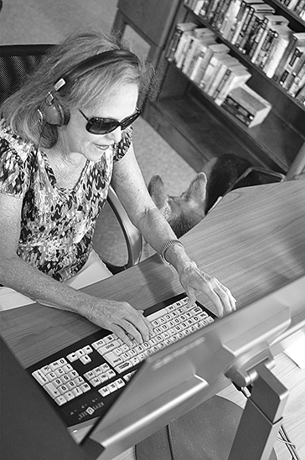The White County Public Library is proud to announce the availability of an accessible computer workstation at the Cleveland Branch in Cleveland, Ga. This workstation was developed with assistive technology to help children and adults with physical or visual disabilities access internet services at the library.

The workstation includes a worktable that can be adjusted for an individual user’s height, including those who use wheelchairs or have other mobility issues. The computer has the current version of the screen reader software JAWS as well as the screen reader NVDA (NonVisual Desktop Access). The computer monitor is a 24” high-definition model loaded with ZoomText software, which allows the screen text to be enlarged easily and clearly.

*Judy Presley using the accessible workstation*

The provision of public internet access is one of the fastest growing, most important services in our Georgia libraries. Offering it to those with accessibility needs takes it a step further.

“The cost of the equipment we are offering is beyond the average person’s capability,” stated Michael Humphrey, program manager of the White County Public Libraries. “There is a growing population of elderly folks in our area. This new service may be of help to those with declining eyesight or physical capabilities.”

This project was made possible by a grant from the Foundation for Rural Service.

The White County Public Libraries are part of the Northeast Regional Library System serving White, Habersham, Stephens and Rabun counties.

## **GLASS Atlanta Contact Information**

1-800-248-6701

glass@georgialibraries.org

55 Park Place NE

Suite 300

Atlanta, GA 30303

Are you working in a public library doing awesome things for patrons with disabilities? GLASS would love to hear about it!

Share what you’re doing with hourglass@georgialibraries.org.

## Books About the Old American West

Note: Talking books begin with DB. Braille titles begin with BR.

*Blood Brothers: The Story of the Strange Friendship Between Sitting Bull and Buffalo Bill* by Deanne Stillman (DB89925, On Bookshare)

The story of the unlikely friendship of Buffalo Bill Cody and Sitting Bull in the 1880s while performing in Cody’s Wild West show. Discusses, among other things, Annie Oakley’s role in their relationship, the rise of the Native American rights movement, and Sitting Bull’s assassination.

*The Western Justice Trilogy* by Gilbert Morris (DB82357, On Bookshare)

Three romantic adventures set in Texas Indian territory. Some violence.

*Cattle Kingdom: The Hidden History of the Cowboy West* by Christopher Knowlton (DB89112, On Bookshare)

A historical account of the few decades following the Civil War known as the open-range cattle era. Discusses how the West rose and fell, its ongoing legacy of cowboy culture, key figures of the period, the killing of millions of bison, cattle drives, and more.

*Blood Oath* by Melissa Lenhardt (DB88078, On Bookshare)

Catherine Bennett is on the run, with every bounty hunter and those wanting to claim the reward for her capture after her. This time she’s got company, and personal demons haunt them both. Unrated.

NLS’ Graphic Novel

NLS created its first talking book version of a graphic novel with the “March” trilogy (DB87098). These award-winning books were written by Georgia’s 5th Congressional District Rep. John Lewis with Andrew Aydin. They cover Rep. Lewis’ experiences in the civil rights movement, including the “Bloody Sunday” march from Selma to Montgomery, Ala. Check it out!

### Call 404-235-7157 to request this newsletter in alternate formats. Join our email list at: hourglass@georgialibraries.org.

HourGLASS our and glass are accentuated

H*our*GLASS is published quarterly by the Georgia Libraries for Accessible Statewide Services (GLASS), a division of Georgia Public Library Service, a unit of the University System of Georgia.

*This publication is made possible by a grant from the U.S. Institute of Museum and Library Services to Georgia Public Library Service under the provisions of the Library Services and Technology Act.*



Text board of regents of the university system of georgia surrounding a house with pillars

**Georgia Libraries** **for Accessible Statewide Services**

Phone: 1-800-248-6701

Fax: 404-657-1459

georgialibraries.org/glass