HourGLASS

www.georgialibraries.org/glass
Volume 6, Issue 1 - Winter 2018

GLASS Atlanta Hosts Open House
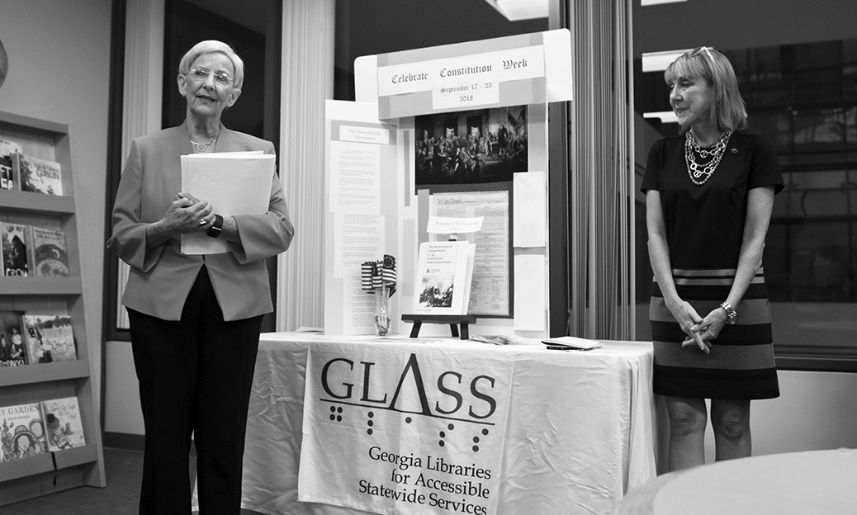On Sept. 20, 2018, GLASS Atlanta celebrated our new facilities with an open house. About 75 attendees came to the open house, including patrons, State Librarian Julie Walker, employees of Georgia Public Library Service and GLASS staff.

The special guest and opening speaker was Georgia’s first lady, Sandra Deal. A supporter of libraries and of childhood literacy, Mrs. Deal stood in front of our display of children’s print/braille books and spoke about the importance of reading, specifically to children, and of serving Georgians with disabilities.
The date of the open house was also near Constitution Day, which is Sept.17. To celebrate, Daughters of the American Revolution member Judy Dyer brought a braille copy of the U.S. Constitution for attendees to read. A tactile American flag allowed attendees to feel the stripes of the flag while reading the pledge in braille.
First Lady Sandra Deal speaks in front of a Constitution Day display with State Librarian Julie Walker
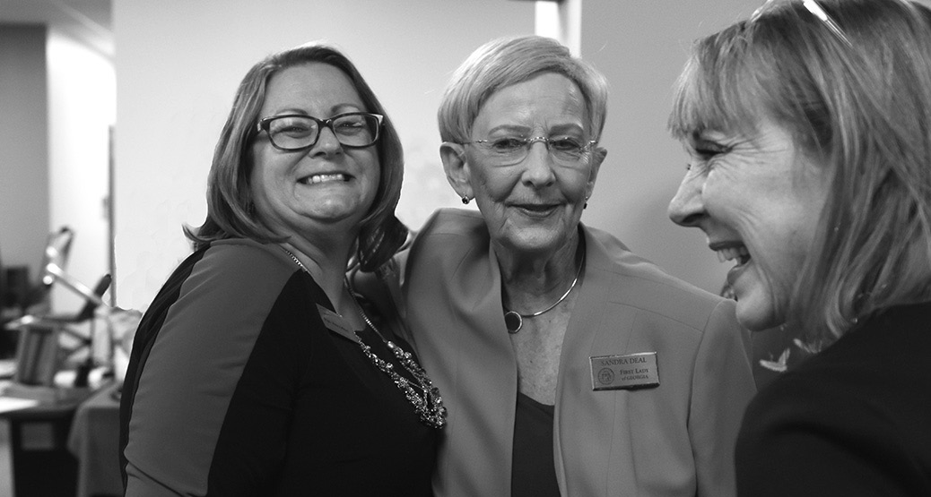
From left to right: GLASS Director Pat Herndon, Mrs. Deal, and Julie Walker.
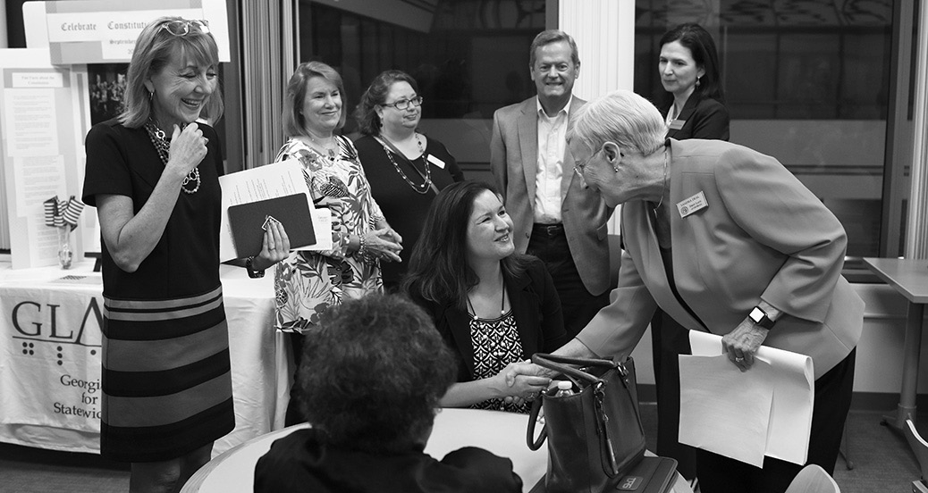Mrs. Deal meeting a GLASS patron

Obituary: Former GLASS Director Stella Cone

We’re sad to share that former GLASS Director Stella Cone passed away Thursday, Sept. 13, after her battle with liver disease.
Stella had a long history of serving people with disabilities. For over 10 years she was head of Disabilities Services with North Dakota State Library. In 2006, her continued work with talking book libraries led her to Georgia where for more than a decade she served, mostly as the director of GLASS. She strove to support people with print impairments, forming bonds
with local, statewide and national organizations to further her work.
Upon her retirement in 2016, she received a plaque of appreciation from the National Library Service for the Blind and Physically Handicapped for her almost 25 years of service. State Librarian Julie Walker joined in the presentation of the award.
We appreciate the work of Stella, and will miss her as our colleague, friend, and advocate for people with disabilities.

Marrakesh Treaty Implementation Act Signed

In October President Trump signed the Marrakesh Treaty Implementation Act. The implementation of this act will allow increased and easier access to copyrighted books in countries that have signed the Marrakesh Treaty.
The Marrakesh Treaty, which was adopted by the World Intellectual Property Organization in 2013, requires adopting countries to make copyright allowances for the creation of accessible books for people with disabilities. This includes books in audio and braille and accessible electronic versions.
The United States joins over 40 countries that have agreed to this treaty, expanding access to accessible reading material in the United States. It will also ease the exchange of materials amongst countries that are signatories for the Marrakesh Treaty, making more accessible books available to readers with disabilities worldwide.
The passing of the Marrakesh Treaty and the push in the United States for implementation of the act are the results of years of hard work by activists and advocates fighting for increased access to copyrighted works.

GLASS Oral History Project

Are you a GLASS patron or eligible to be a GLASS patron? Would you like to share your story as someone with a disability? We’d love to talk with you!
The GLASS Oral History Project: Our Stories, Our Lives is in its beginning stages, and is being undertaken as a joint project with the Russell Library, a part of the University of Georgia Libraries, Special Collections.
For more details, call 404-235-7157 and leave a message, or you can email sirvin@georgialibraries.org.

Books About Pursuing Happiness

Note: Talking books begin with DB.
Braille titles begin with BR.
You Can Buy Happiness (And It’s Cheap): How One Woman Radically Simplified Her Life and How You Can Too by Tammy Strobel (DB75531, BR019659, On Bookshare)
A simple-living blogger gives advice for reducing reliance on material possessions, using time effectively, and recognizing the power of simple pleasures. Covers managing debt and creating a meaningful work life.
Happiness Is a Choice You Make: Lessons From a Year Among the Oldest Old by John Leland (DB90123, BR022290, On Bookshare)
A journalist interviews six men and women, all over the age of 85, who share the importance of focusing on enjoying all one still can do.
The Mayo Clinic Handbook for Happiness: A 4-Step Plan for Resilient Living by Amit Sood, Mayo Clinic (DBC02865, On Bookshare)
This book combines wisdom from neuroscience, psychology, philosophy, and spirituality to help you learn to be happy and to choose contentment.
Happy for No Reason: 7 Steps To Being Happy From the Inside Out by Marci Shimoffi; Carol Kline (DB66372, BR017746, On Bookshare)
The authors present a seven-step, holistic approach to finding lasting happiness.
Dr. Burns’ Prescription for Happiness by George Burns (DB21211, On Bookshare)
Humorous anecdotes, one-liners, and personal observations by the octogenarian comedian.

FREE MATTER FOR THE BLIND AND PHYSICALLY HANDICAPPED
Georgia Libraries for Accessible Statewide Services
1800 Century Place, Suite 580
Atlanta, GA 30345

Donate to GLASS
GLASS appreciates monetary donations, which can be used to serve patrons across Georgia. Donations made to the USG Foundation and designated for “GLASS Fund” are used to support GLASS programming.
For detailed information on monetary donations, visit www.georgialibraries. org/glass/donate.

Call 800-248-6701 to request this newsletter in alternate formats. Join our email list at: hourglass@georgialibraries.org
HourGLASS is published quarterly by the Georgia Libraries for Accessible Statewide Services (GLASS), a division of Georgia Public Library Service, a unit of the University System of Georgia.
This publication is made possible by a grant from the U.S. Institute of Museum and Library Services to Georgia Public Library Service under the provisions of the Library Services and Technology Act.
Georgia Libraries
for Accessible Statewide Services
Toll Free: 1-800-248-6701
Fax: 404-657-1459
www.georgialibraries.org/glass

