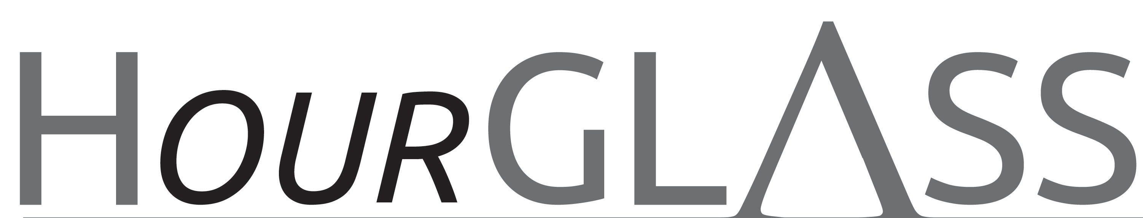

www.georgialibraries.org/glass
Volume 6, Issue 3 - Summer 2019

Georgia Accessibility Conference a Success

Since 2015, GLASS has held the Georgia Accessibility Conference (GAC) with the purpose of educating library staff in Georgia on various topics regarding accessibility, including how to serve Georgia public library patrons with disabilities. The GAC supports the mission of GLASS to support accessible services in Georgia and awareness of the talking book program.
The 2019 conference hosted attendees from 45 public library systems, as well as Georgia Public Library Service staff. Feedback from the conference was excellent, both attendees and those presenting walking away with expanded knowledge of GLASS, accessible services and serving people with disabilities.

Newly Formed Friends Group Supports GLASS

GLASS is excited to announce the formation of the Friends of Georgia Libraries for Accessible Services. The Friends of GLASS is a separate organization from GLASS and is made up of people just like you: GLASS users, their families, organizations, and supporters who care about enriching the services of GLASS.
For the past few months a group of hardworking volunteers worked to establish the Friends group, developed the bylaws and elected a board of trustees.

The role of the Friends group is to generate funds, over and above GLASS operating budget, to provide support for GLASS programs or special events and to establish a volunteer base.
As a Friend of GLASS you will join a community of people who value the services of GLASS. Please help GLASS grow our Friends! To join, call GLASS at 800-248-6701, visit the Friends page at www.georgialibraries.org/glass/friends or you can also mail or drop off the application on the next page of this newsletter.

Friends of Georgia Libraries for Accessible Statewide Services-Atlanta, Inc.

Membership Form

Friends is an association of persons interested in Georgia Libraries for Accessible Statewide Services who provide support for and advocate on behalf of Georgia Libraries for Accessible Statewide Services

Contact Information

First name: Last name:

Phone #: Email:

Address:

City: State: Zip code:

Annual Membership Options

☐Individual
$10-$249
☐Bronze
$250-$499
☐Silver
$500-749
☐Gold
$750-$999
☐Platinum
$1000 +

Payment Method
For check or money order payments
Make payable to Friends of Georgia Libraries for Accessible Statewide Services-Atlanta, Inc.

55 Park Place NE, Suite 300, Atlanta, Georgia 30303

Amount US$:
For credit card payment
Select credit card: ☐MasterCard ☐Visa ☐AMEX ☐Discover

Amount US$: Card #:

CVV: Expiration date:

Name on card: Signature:

Georgia Radio Reading Service

Have you heard about the Georgia Radio Reading service or GARRS? GARRS provides readings of newspapers, magazines, service programs and books to listeners across Georgia who are print impaired or visually impaired. Programming is available free of charge, and there are a variety of ways to listen. GARRS can send you a radio to pick up the signal, or you can listen on any smart device using the TuneIn app or Sero app. If you would rather choose your programming, you can listen on demand using the program library on the garrs.org website, or you can access the telephone reader system using any phone. For questions or to sign up, please call Karen Pennerman at 404-685-2832 or you can email her at listen@garrs.org.

Books About the Power of Friendship

Note: Talking books begin with DB. Braille titles begin with BR.

Franklin and Winston: An Intimate Portrait of an Epic Friendship by Jon Meacham (DB57644, On Bookshare) Chronicles the vital friendship between British Prime Minister Winston Churchill and U.S. President Franklin D. Roosevelt in the years 1939-1945.
Andy and Don: The Making of a Friendship and a Classic American TV Show by Daniel De Visé (DB87442, On Bookshare)
This dual biography of actors Andy Griffith and Don Knotts, including stories of their personal lives and careers, also covers the making of “The Andy Griffith Show.”
We Beat the Street: How a Friendship Pact Led to Success by Sampson Davis et al. (DB61182, On Bookshare) Personal accounts of three childhood friends in New Jersey, who made a pact to finish high school, go to college and attend medical school. Describes the power of their mutual support to help them overcome poverty and community violence and become role models for others. For grades 6 through 9.
Making Friends by Fred Rogers (DB27341, BR007148, On Bookshare) Mr. Rogers explains what it means to be friends, and how friendship can make you feel left out, angry or sad, as well as happy and full of joy. For preschool through grade 2.

A newsletter for friends of the Georgia Library for Accessible Statewide Services
Georgia Libraries for Accessible Statewide Services
1800 Century Place, Suite 580
Atlanta, GA 30345
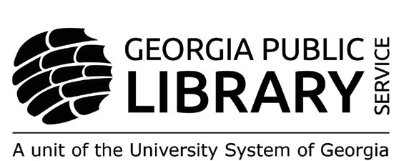

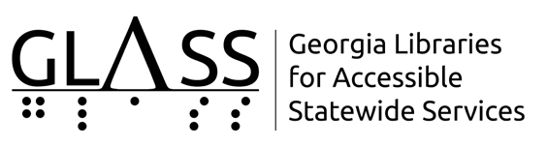

Newsletter by Email
Are you interested in receiving this newsletter by email? The HourGLASS is sent by email with links to accessible versions so you can read it how you would like!
Call GLASS at 800-248-6701 to let us know you’d like to be on our email mailing list. You can also email us at hourglass@georgialibraries.org.

HourGLASS is published quarterly by the Georgia Libraries for Accessible Statewide Services (GLASS), a division of Georgia Public Library Service, a unit of the University System of Georgia.
This publication is made possible by a grant from the U.S. Institute of Museum and Library Services to Georgia Public Library Service under the provisions of the Library Services and Technology Act.

Georgia Libraries
for Accessible Statewide Services

Toll Free: 1-800-248-6701
Fax: 404-657-1459 www.georgialibraries.org/glass

