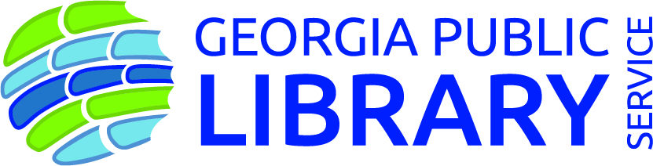
New oral history collection documents disability experience in Georgia
“We heard such a variety of beautiful stories that exemplify both how unique our patrons are and the rich lives they have; this collection challenges the general perception of what it means to live with disability.”

June 20, 2019
CONTACT: Deborah Hakes, dhakes@georgialibraries.org

ATLANTA...Georgia Public Library Service is pleased to announce the release of Our Stories, Our Lives, an oral history collection of stories to preserve and document a more complete history of the disability experience, specifically that of people with print disabilities who are living in Georgia.

“Interviewees shared their experiences with us, whether it was a life story or a period of time that was significant to them,” said Georgia Libraries for Accessible Statewide Services (GLASS) Outreach Librarian Stephanie Irvin, who managed the project. “We heard such a variety of beautiful stories that exemplify both how unique our patrons are and the rich lives they have; this collection challenges the general perception of what it means to live with disability.”

Through GLASS, the Georgia Public Library Service provides library services for individuals who are blind and to those whose physical abilities require the use of books and magazines in audio format or in braille. GLASS talking book and large-print library has more than 450,000 annual checkouts, and users who are physically unable to visit a library can obtain materials freely by mail.

Audio interviews and transcripts maintain the authentic voices of people who have a print disability, including visual impairment, physical impairment, blindness or a reading disability.

“GLASS was pleased to curate Our Stories, Our Lives to show disability is not a one-size-fits-all experience as a part of our ongoing efforts to promote accessible library services in Georgia,” said Assistant State Librarian and GLASS Director Pat Herndon.

The digital repository of Our Stories, Our Lives is hosted by the Richard B. Russell Library for Political Research and Studies, who partnered with GLASS to archive the project.

Access the collection through http://georgialibraries.org/glass/ourstories/

####

About Georgia Public Library Service
Georgia Public Library Service (GPLS) empowers libraries to improve the lives of all Georgians by encouraging reading, literacy, and education through the continuing support and improvement of our public libraries. GPLS is a unit of the Board of Regents of the University System of Georgia. www.georgialibraries.org#georgialibraries

About the Georgia Libraries for Accessible Statewide Services
Georgia Libraries for Accessible Statewide Services (GLASS) supports accessible library services in Georgia by promoting the use of assistive technology and by providing accessible reading materials to those who, due to a disability, are unable to read standard print.

This partnership is paid for in part by a grant to the Georgia Public Library Service from the Institute of Museum and Library Services under the Library Services and Technology Act.

