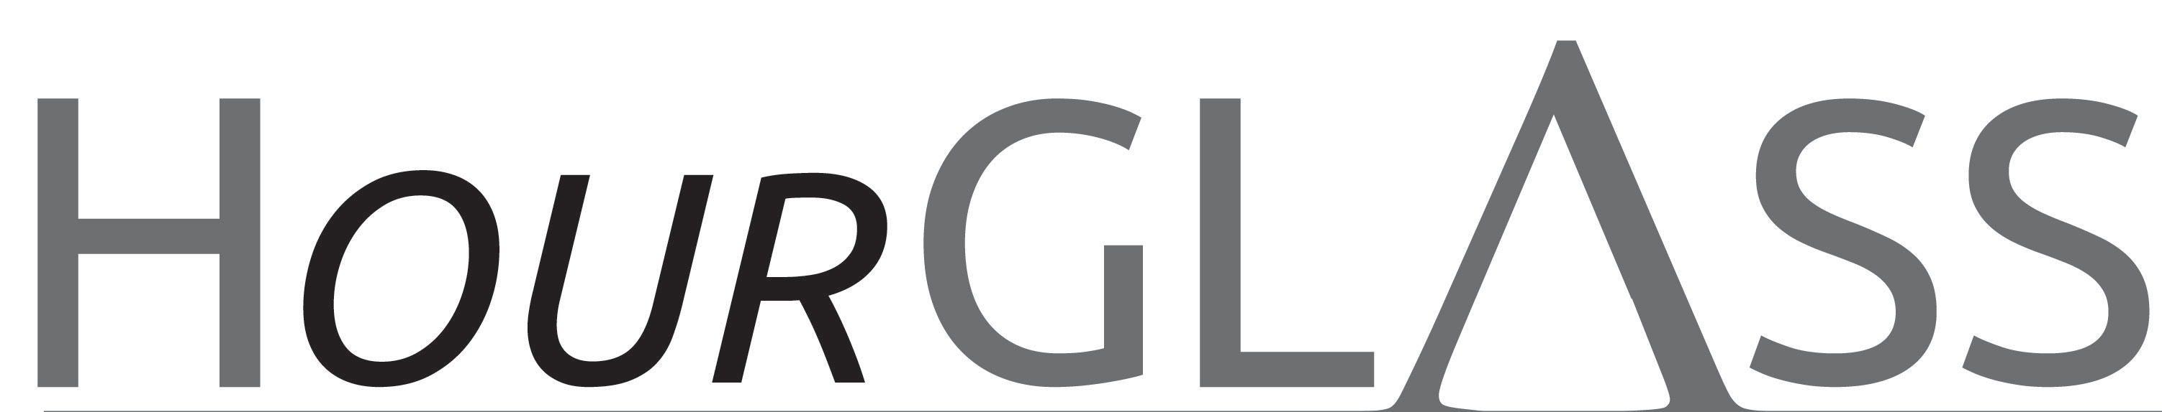

www.georgialibraries.org/glass
Volume 6, Issue 4 - Fall 2019

U.S. Currency Reader

Telling one bill from another can be an issue for those with limited vision. A system of folding money in specific ways to tell the ones from the twenties can help. For instance, $1 bills can be left plain, $5 bills folded lengthwise, $10 bills by width, and $20 bills lengthwise and then by width. This system is great for paying out, but what about receiving money?
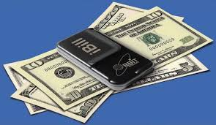
The Bureau of Engraving and Printing to the rescue! BEP will provide blind and visually impaired citizens and legal residents a “talking” currency reader at no cost. Visit https://www.moneyfactory.gov/uscurrencyreaderpgm.html for an application. You can also
call (844) 815-9388 toll-free or email meaningful.access@bep.gov.

Rediscover Bookshare
GLASS loves to partner with folks who are as passionate about accessible reading materials as we are. Bookshare is one such partner, providing access to over 700,000 titles. Like every other service that we provide, GLASS patrons enjoy Bookshare at no cost. We only ask that you use it, because we’d hate for you to lose it!
It’s important to note that nonuse of your Bookshare account will result in account deactivation and removal from the GLASS promo account. This step preserves memberships for patrons who will use and enjoy the service.
Give us a call if you’ve been removed and want to continue to access Bookshare’s library of textbooks, best-sellers, children’s books, career resources and more. 1-800-248-6701

Southwest Georgia Library for Accessible Services

If you live in metro-Atlanta, you may have had the pleasure of visiting GLASS Atlanta for one of our programs or to use JAWS magnifying software on the computers. GLASS Atlanta provides patron services to all parts of the state except the following 22 county region: Baker, Brooks, Calhoun, Clay, Colquitt, Decatur, Dougherty, Early, Echols, Grady, Lanier, Lee, Lowndes, Miller, Mitchell, Quitman, Randolph, Seminole, Terrell, Thomas, Webster, and Worth.

For those counties, it’s Southwest Georgia Library for Accessible Services (SWGLAS) to the rescue! SWGLAS is a sub-regional in the GLASS system that provides both patron service and outreach within their service area. SWGLAS is always looking for new ways to increase awareness of the services that we can offer to the members of our community. Any time we do community outreach for the public library, the Southwest Georgia Regional Library system, we hand out promotional materials for SWGLAS, and provide information with regard to ways SWGLAS can partner with the community and who qualifies for the services.

These outreach events include Family Connection meetings, health fairs, community events, school programs and more. At these events, people often mention people they know who could utilize these services, and they often express that they were not aware that this was available to them. These exchanges highlight the importance of reaching our community face to face, identifying potential users and demonstrating the value of our materials and services for improving their quality of life. We love getting the word out! Online information and social media are useful tools to provide information for potential users, but interacting with them in person can be a very important part of establishing connections with stakeholders. Many of our potential users are often not able to visit the libraries in the rural 22-county region that SWGLAS covers, so it is vital that we meet them where they are. If you live in the South West region and would like to learn more about our services, please call 229-248-2680

Fall in love with this cider

Cooking Light magazine (available in BARD in braille) shares this Fall Harvest Cider recipe perfect for a crisp autumn

day!
Cook safely and enjoy!
Ingredients
4 cups apple cider
1/4 cup fresh orange juice
10 black peppercorns
6 whole cloves
5 whole white cardamom pods
3 thick lemon slices
4 crushed star anise
3 cinnamon sticks
1 piece of peeled fresh ginger, thinly sliced (or packaged ginger)
Combine all ingredients in a slow cooker on high heat (place solid ingredients in cheesecloth if you prefer not to strain). Cook for 30 to 45 minutes. Strain cider mixture through a fine sieve over a bowl, and discard solids. Serve cider hot.
A newsletter for friends o

Books about Change

Walden by Henry David Thoreau (DB15949, On Bookshare) Autobiography recording the author’s experiment in essential living at his Walden Pond retreat in the 1850s, as well as his detailed observations of nature and his commentaries on world problems.

Becoming by Michelle Obama (DB92627, On Bookshare) Obama recounts her childhood in Chicago, her years balancing motherhood and her career as an executive, and her time in the White House.

Shifting Gears: how to master career change and find the work that’s right for you by Carole Hyatt (DB 33356) Hyatt, a market and social behavior researcher, interviewed more than 300 people who have been successful in “shifting gears.”

First Frost: A Novel by Sarah Addison Allen (DB80865, On Bookshare) Claire’s new candy business is taking her further and further away from her family, Sydney wants another baby, and teenage Bay is navigating the waters of first love.

Seeking a friend
As a Friend of GLASS you will join a community of people who value the services of GLASS. Please help GLASS grow our Friends! To join, call GLASS at 800-248-6701, or visit the Friends page at www.georgialibraries.org/glass/friends where you can print and mail (or drop off) the application found there.
HourGLASS is published quarterly by the Georgia Libraries for Accessible Statewide Services (GLASS), a division of Georgia Public Library Service, a unit of the University System of Georgia.
This publication is made possible by a grant from the U.S. Institute of Museum and Library Services to Georgia Public Library Service under the provisions of the Library Services and Technology Act
Georgia Libraries for Accessible Statewide Services
1800 Century Place, Suite 580
Atlanta, GA 30345
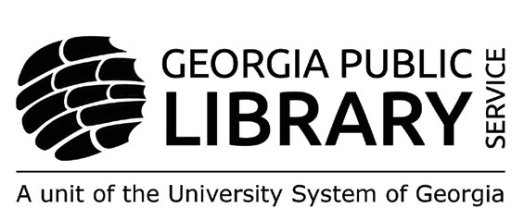

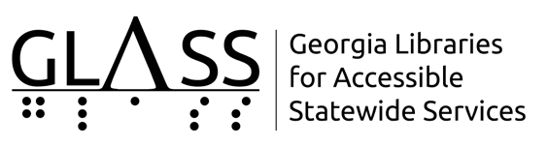

Newsletter by Email
Are you interested in receiving this newsletter by email? The HourGLASS is sent by email with links to accessible versions so you can read it how you would like!
Call GLASS at 800-248-6701 to let us know you’d like to be on our email mailing list. You can also email us at hourglass@georgialibraries.org.

HourGLASS is published quarterly by the Georgia Libraries for Accessible Statewide Services (GLASS), a division of Georgia Public Library Service, a unit of the University System of Georgia.
This publication is made possible by a grant from the U.S. Institute of Museum and Library Services to Georgia Public Library Service under the provisions of the Library Services and Technology Act.

Georgia Libraries
for Accessible Statewide Services

Toll Free: 1-800-248-6701
Fax: 404-657-1459 www.georgialibraries.org/glass

