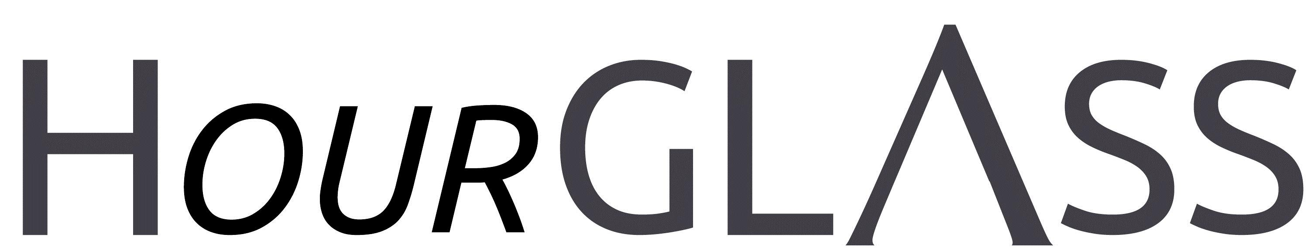

www.georgialibraries.org/glass

Have you heard?

The Library of Congress’s National Li-brary Service for the Blind and Physical-ly Handicapped (NLS), which provides braille and audio materials to GLASS, has changed its name. As of Oct. 1, 2019, it will be known as “National Li-brary Service for the Blind and Print Disabled.”

The new name addresses the use of outdated language and more clearly communicates the breadth of those served. NLS sought input on this name change implementation from stakehold-er groups and gathered data through various public channels, including its users.
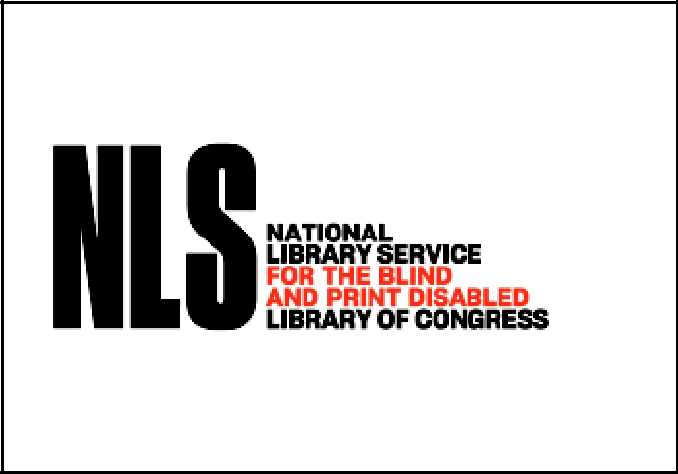

Volume 7, Issue 1, Winter 2019

Circadian Rhythm Disorder

Approximately 10% of the 1.3 million blind people in the United States have no light perception, which may mean their bodies do not sync to the 24-hour clock. As many as half to three-quar-ters of the totally blind, approximately 65,000 to 95,000 Americans, have Non-24 Free-Running Disorder.

Non-24 can cause sleep deprivation and have long-term e ects on health. Depression, anxiety disorders, lowered immune response, weight gain, fibromy-algia, diabetes and cancer may result. Work and study may su er from an in-ability to concentrate.

Some doctors might recommend pre-scription drugs, light therapy, and/or “sleep hygiene” habits to entrain the patient to a 24-hour cycle. But a nor-mal sleep schedule may be di cult or impossible for some Non-24 subjects. Curious about alternative solutions? It may be helpful to focus on your natural pattern of sleep and wakefulness, not relying on the clock, but sleeping when you’re tired.

A newsletter for friends of the Georgia Library for Accessible Statewide Services

Duplication on Demand: A message from the GLASS Director

Dear Talking Book Patron:

The National Library Service for the Blind and Print Disabled (NLS) is phasing out its program of recording a single book on a single digital cartridge. Instead, library patrons will receive custom-ized cartridges that include several books that have been queued for delivery to the individual.

The new service will involve the same digital talking book machines and the same style cartridges. The books will come to you in the same cases and will have the return address already a xed to the case. Return mail will be even easier as you will no longer need to turn over the mailing card or match the card to the cartridge. When you receive your cartridge, you will find that the mail-ing card has the book titles printed on the back of the card. Additionally, the cartridge will have an audio index of titles on the cartridge. When you put the cartridge into the digital talking book machine, a narrator will explain how to navigate between titles on the cartridge allowing you to navigate from title to title so that you may read the books in the order that you wish to read.

There are several advantages for library patrons under this new program. Most importantly, you will now have access to the complete catalog of all digital talking books in the NLS program. You will never be in line waiting for a specific book cartridge to be returned by another patron. All books are available all of the time! New titles will be available much quicker than when our library had to wait on shipment from NLS. An added bonus is that you will have fewer cartridges to keep up with.

GLASS is not the fi rst NLS library to use duplication on demand. We will be following in the foot-steps of many other talking book libraries. We have spoken to those librarians so that we can anticipate any concerns that patrons may have. What we have learned is that most patrons really like the new system. Some admit that it took a bit of time to get used to, but once accustomed to it, they also like the new service. Others shared some concerns that seem to reflect individual preferences for how they would want material organized on a cartridge. The good news is that the Reader Advisors at GLASS Atlanta and at SWGLS are prepared to assist you. We want to make sure that you continue to enjoy your digital talking books. For assistance, call 1-800-248-6701 to speak to sta at GLASS Atlanta, or those served by Southwest Georgia Library for Accessible Ser-vices may call 800-795-2680.

Stay tuned, GLASS will soon use duplication on demand to meet the requests of every GLASS patron. Thank you for being patient during this exciting time of transition!

Sincerely,

Pat Herndon

Assistant State Librarian & Director of GLASS

A newsletter for friends of the Georgia Library for Accessible Statewide Services

Holiday Reminders

The winter holiday season is one of Halloween: Regular hours

the busiest times of the year for talking Veteran’s day: Regular hours

books and braille libraries! Books tend Thanksgiving: Closed Thanksgiving Day

to check out quickly, particularly books and November 29

about Christmas. Christmas: Closed Christmas Eve and

Call 1-800-248-6701 to reserve your Christmas Day

books early. This is especially important New Year’s: Closed New Year’s Eve and

if you will be traveling and want books New Year’s Day

to read on the road.

Note, GLASS Atlanta will observe the

following holiday hours:

Books About Holidays

Note: Talking books begin with DB. Braille titles begin with BR.

A Frontier Christmas by William W. Johnstone (DBC12877, On Bookshare) After the Mayor of Chugwater, Wyoming, and his family are brutally murdered, Du MacCallister captures the killers but they escape the night before their hanging. Then, diphtheria breaks out in town and Smoke, Sally and Matt Jensen - who have come to spend Christmas with Du - are forced to negotiate with the outlaws to save the townspeople.

To Every Season: A Holiday Family Cookbook by Jane B. Zalben (BR14146, On Bookshare) This title presents a brief history of holidays throughout the calen-dar year with recipes for traditional favorites. Covers New Year’s, Valentine’s, St. Patrick’s, April Fools’, Easter, Passover, Mother’s Day, Memorial Day, Father’s Day, Fourth of July, Labor Day, Halloween, Thanksgiving, Chanukah (or Hanukkah?), Kwanzaa, and Christmas. For grades 4-7 and older readers. 1999.

The Power of Light: Eight Stories for Hanukkah by Isaac B. Singer (DB 71860) A collection of eight tales--one for each night of Hanukkah--by Nobel laureate Isaac Bashevis Singer (1904-1991). In “The Parakeet Named Dreidel” a pet lost in Brook-lyn on the eighth night of Hanukkah eventually unites his former and current owners through love. For grades 4-7 and older readers. 1980.

A newsletter for friends of the Georgia Library for Accessible Statewide Services

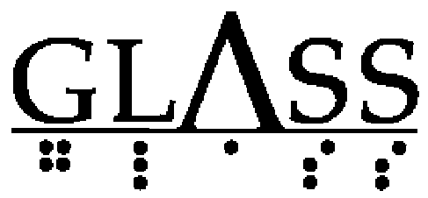
FREE MATTER

FOR THE BLIND

AND PHYSICALLY

HANDICAPPED

Georgia Libraries for Accessible Statewide Services 2872 Woodcock Blvd, Suite 250, Atlanta, GA 30341

nn

Newsletter by email

Are you interested in receiving this newsletter by email? The HourGLASS is sent by email with links to accessible versions so you can read it how you would like!

Call GLASS at 800-248-6701 to let us know you’d like to be on our email mail-ing list. You can also email us at hour-glass@georgialibraries.org.

Call 404-235-7157 to request this newsletter in alternate formats. Join our email list at: hourglass@georgialibraries.org

HourGLASS is published quarterly by the Georgia Libraries for Accessible Statewide Services (GLASS), a division of Georgia Public Library Service, a unit of the University System of Georgia.

This publication is made possible by a grant from the U.S. Institute of Museum and Library Services to Georgia Public Library Service under the provisions of the Library Services and Technology Act.

Georgia Libraries

for Accessible Statewide Services 2872 Woodcock Blvd, Suite 250 Atlanta, GA 30341 Phone: 404-235-7200

Toll Free: 1-800-248-6701 Fax: 404-235-7201 www.georgialibraries.org/glass

