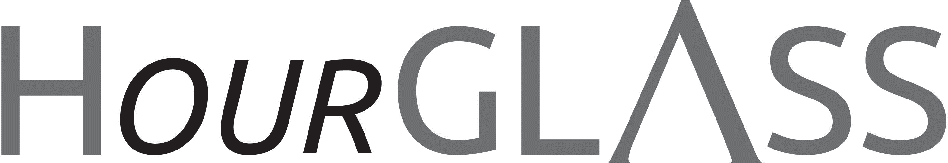

www.georgialibraries.org/glass

Census 2020

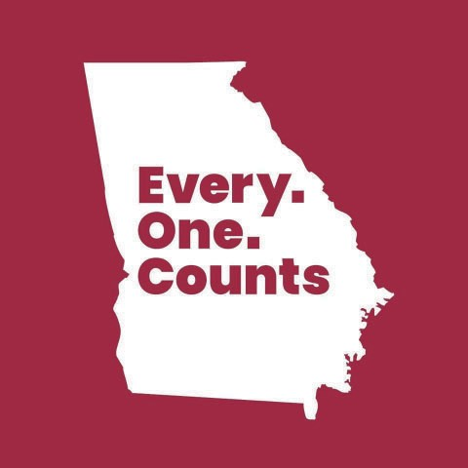
Census 2020 is upon us and the organi- zation’s big message is that Every. One. Counts.

Per the Census website, www.2020census.gov, “The census pro- vides critical data that lawmakers, business owners, teachers, and many others use to provide daily services, products, and sup- port for you and your community.”
Public libraries are essential to the process of providing information about the census and educating the community on how to participate in it. For the first time ever the census can be taken online, and libraries are prepared to help ensure an inclusive and complete count of our nation’s resi- dents. The census survey can be delivered
Volume 7, Issue 2, Spring 2020 in various formats including online, phone, or in-person. Please note that GLASS can direct patrons to the format that works best for your accessibility needs but GLASS staﬀ cannot fill out the form for patrons.
Here are some important dates to keep in mind:
- March 12 - 20: Households will begin receiving oﬃcial Census Bureau mail with detailed information on how to respond to the 2020 Census online, by phone, or by mail.
- March 30 - April 1: The Census Bu- reau will count people who are experienc- ing homelessness over these three days. As part of this process, the Census Bureau counts people in shelters, at soup kitchens and mobile food vans, on the streets, and at nonsheltered, outdoor locations such as tent encampments.
- April 1: Census Day is observed nationwide. By this date, every home will receive an invitation to participate in the 2020 Census. Once the invitation arrives, you should respond for your home in one of three ways: online, by phone, or by mail. When you respond to the census, you’ll tell the Census Bureau where you live as of April 1, 2020.
A newsletter for friends of the Georgia Library for Accessible Statewide Services

Apology! Due to a clerical error, some subscribers experienced trouble with the delivery of the last issue. We have spoken to several of you but wanted to take this opportunity to oﬀer further apology for
the inconvenience and to thank you for your patience!
Got a question about the service? Ask GLASS!
The GLASS outreach team often fields questions from patrons while at events. The outreach team invited other GLASS staﬀ to help answer some questions!

Q. I currently only read with the talking book player. I may try to read a book on my phone with BARD Mobile. Will it work with my phone screen reader? Is BARD Mobile better than my player?

A. Yes, BARD Mobile works with your phone’s screen reader. It works with voice-over on the iPhone and Talkback on Android devices. Depending on your phone’s speaker, it may not play as loud as your digital player, but it is more convenient to download books directly to your phone. Also, it’s more portable. -Jason Phillips, GLASS Reader Advisor

Q. I know GLASS is a little diﬀerent from traditional libraries but do you oﬀer programs too?

A. Yes, we oﬀer programs and we have several programs we’re excited to share with you! Our programs include: keyboarding class (typing), iPhone using voice-over and dictation, For Grown Folks Only book club (face-to-face), GLASS peer support group (via phone conference). The support group meets every third Wednesday from 2:00-4:00 p.m. except July, November and December. On December 19th our patrons enjoyed the GLASS Holiday Talent Variety Show produced by GLASS staﬀ and attended by patrons of GLASS as well
as of the Decatur Library who graciously provided the venue. -Vanessa Meadows, GLASS Atlanta Assistant Manager
Don’t let a good thing go!
Georgia Libraries for Accessible Statewide Services is pleased to oﬀer a variety of platforms to our patrons for their reading pleasure. It is important to be mindful that many of our subscription services have a “use it or lose it” policy. Although, all of these services can be reinstated with a quick phone call, a lack of usage triggers a suspension in service. Your Bookshare account must be used at least once every 6 months to keep it active. BARD and BARD Mobile must be used at least once every 6 months to enjoy those services uninterrupted. For those patrons that receive Braille books from Utah, the service must be used once every 18 months to keep an account active.

Yes, we’d love your support!

GLASS encourages and welcomes monetary gifts, bequests, endowments, and memorial or honorary contributions. These gifts help enrich and improve library services. Monetary contributions are added to the University System of Georgia Foundation Fund (EIN 58-6333106), which is allocated by the Georgia Public Library Service to purchase materials or equipment or to support library programs not covered in the GLASS operations
budget. The GLASS-sponsored patron prom and the Holiday Variety Show were made possible through your contributions to the foundation fund! Check out the pictures on our Facebook!
Donations accepted by GLASS shall be final with no restrictions on using the gift. GLASS will provide timely, written acknowledgments of the receipt of gifts. For detailed informa- tion on monetary donations, visit www.geor- gialibraries.org/glass/donate

Books About Entrepreneurship
Note: Talking books begin with DB. Braille titles begin with BR.
Burn the business plan: what great entrepreneurs really do by Carl J. Schramm (DB90774, On Bookshare) Economist and entrepreneur presents an argument that business plans are not vital to the success of entrepreneurial ventures. Oﬀers advice for aspiring entrepreneurs, examines reasons for the failures of startup businesses, discusses planning for the success of a business, and more. 2018.

Clay, water, brick: finding inspiration from entrepreneurs who do the most with the least by Jessica Jackley (DB82861, On Bookshare) Co-founder of microlending service Kiva, which specializes in crowd-sourced entrepreneurial loans to individuals in
underdeveloped countries, shares her experiences in developing Kiva and the lessons she has learned. She uses stories of entrepreneurs to highlight points of advice. 2015.

Going for it!: how to succeed as an entrepreneur by Victor Kiam (DB24802) According to the author, an entrepreneur is or can be anyone who sees little diﬀerence between obstacle and opportunity and is able to capitalize on either. Kiam shares personal remembrances and oﬀers credible, useful advice to beginners and professionals alike.
1986.

Leapfrog: the new revolution for women entrepreneurs by Nathalie Molina Niño (DB93968, On Bookshare) Technologist and founder of an investment company dedicated to assisting innovative businesses geared toward women presents 50 hacks for women entrepreneurs to level up their businesses. Topics addressed include mindset, identifying networks, funding stages, and growing your company. Unrated. Commercial audiobook.
2018.

Georgia Libraries for Accessible Statewide Services
FREE MATTER FOR THE BLIND AND PHYSICALLY HANDICAPPED

2872 Woodcock Boulevard, Suite 200
Atlanta, GA 30341

Newsletter by email

Are you interested in receiving this newsletter by email? The HourGLASS is sent by email with links to accessible versions so you can read it how you would like!

Call GLASS at 800-248-6701 to let us know you’d like to be on our email mail- ing list. You can also email us at hour- glass@georgialibraries.org.
Call 800-248-6701 to request this newsletter in alternate formats.
Join our email list at: hourglass@georgialibraries.org

HourGLASS is published quarterly by the Georgia Libraries for Accessible Statewide Services (GLASS), a division of Georgia Public Library Service, a unit of the University System of Georgia.
This publication is made possible by a grant from the U.S. Institute of Museum and Library Services to Georgia Public Library Service under the provisions of the Library Services and Technology Act.

Georgia Libraries
for Accessible Statewide Services

Toll Free: 1-800-248-6701
Fax: 404-657-1459
www.georgialibraries.org/glass

