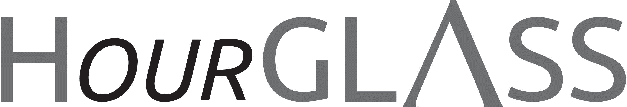

www.georgialibraries.org/glass

GLASS & COVID-19

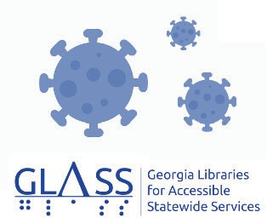

These have certainly been unprecedented times. We here at GLASS are continuing to prioritize the health of our patrons as well as our staﬀ, and as such we’re not operat- ing at our normal capacity. The following are the various ways that our program has shifted to adjust to the challenge of CO- VID-19.
We are oﬀering a temporary application approval process to ensure that those who are interested in completing an applica- tion can do so unhindered by the signature requirement. Recognizing that obtaining
Volume 7, Issue 3, Summer 2020 a “wet” (pen on paper) signature might prove challenging, we provide an alternate process to get your application certified.

Further instruction is available on the CO- VID-19 page of our website. We are no longer circulating talking book machines and cartridges from the NLS collection.
However, thanks to an arrangement with Utah State Library, we are able to lend
a limited number of book cartridges to patrons who are unable to use BARD or BARD Mobile. These will be the traditional cartridges with one book per cartridge.
The books are mailed out from Utah and should be returned to Utah. Remember to keep the mailing card on the case to use to return the cartridge to Utah when you have finished. To request a book from Utah, you must call GLASS at 800-248-6701.
Summer Reading!

Stay tuned for Summer Reading! This year’s theme is Imagine Your
Story. Encourage your young readers to read and keep a log. The virtual pro- gram is set to run from June 1 to July 31, 2020. Look for the reading list to be up on GLASS website before the end of May. georgialibraries.org/glass

A newsletter for friends of the Georgia Library for Accessible Statewide Services

The End of an era…the start of something new
A message from GLASS Director, Patricia Herndon: After serving print disabled readers in southwest Georgia since 1974, Southwest Georgia Library for Accessible Services (SWGLAS), housed at
the Gilbert H. Gragg Library in Bainbridge, will no longer be operating as a GLASS subregional library. GLASS is moving into its final phase of program consolidation that began in 2015. GLASS is appreciative to Southwest Georgia Regional Library for the superb level of service that their staﬀ has provided to GLASS patrons for many years. Our thanks go out to Susan Whittle, director of Southwest Georgia Regional Library and SWGLAS, and to her wonderful library team.

Technology has had a major impact on talking book services across the nation. The National Library Service for the Blind and Print Disabled (NLS) is transitioning from distributing single books on single cartridges to a system where they still select, catalog and record books but distribute them to the state libraries only in digital format. The new system is called duplication on demand. Staﬀ at the GLASS Distribution Center in Morrow, Georgia, will create individualized digital cartridges for all GLASS patrons. Those cartridges may hold up to 10 books each. The cartridges are customized
to the interests and requests of the reader. NLS provided the hardware and software to the GLASS Distribution Center to create these individualized cartridges. NLS is gradually working to stop production of the individual cartridges as NLS network libraries across the country transition to duplication on demand. Since SWGLAS will no longer be housing a current collection of digital
cartridges and with the availability of a toll-free phone line, all eligible Georgians will be served by the team of reader advisors in Atlanta and the book production staﬀ in Morrow.

Change is hard. But change can be good as well. Technology will continue to impact the way that GLASS provides services to our eligible readers. We at GLASS are looking forward to all that the future holds. We are committed to serving our patrons with responsive service that is customized to the needs of the individual. The reader advisors in Atlanta are friendly people who love helping our patrons. They can help you select the next book and even invite you to a telephone book club! They are happy to help and are looking forward to working with the patrons from southwest Georgia. Just give them a call at 1-800-248-6701.
NFB NEWSLINE book club

GLASS is partnering with NFB (National Federation of the Blind) NEWSLINE to provide an exciting phone-based book club opportunity. The NFB team will upload the classic novel The Great Gatsby by F. Scott Fitzgerald to the GLASS local channel of NFB-NEWSLINE, and it will soon be available for your reading pleasure. This is an audible format, and they’ve added a special feature to allow the listener to bookmark their location in the book by entering a “1” to mark their place (to the sentence) in the book that they are listening to. NFB-NEWSLINE is a free audio news service for anyone
who is blind, low-vision, deafblind, or otherwise print-disabled and oﬀers access to more than 500 publications, emergency weather alerts, job listings, and more. If you are interested in registering for this service, call GLASS at 1-800-248-6701.

Peer Support

GLASS Atlanta Assistant Manager Vanessa Meadows oﬀers a conference- call-based peer support group for the visually impaired every third Wednesday of each month. At February’s meeting they welcomed two inspectors from the Atlanta Police Department who spoke on safety measures and avoiding scams. The March meeting focused on the coronavirus concerns. Participants shared how it has impacted their lives and oﬀered words
words of encouragement. The group dis- cussed ways to combat the anxiety of in- creased social isolation and shared laughs and reassurance.

The conference call number is 1-605-475- 6777, access code 1959. For more informa- tion please call Vanessa at 678-592-2929.

Hot Summer Reads!
Note: Talking books begin with DB. Braille titles begin with BR.

The Bookish Life of Nina Hill by Abbi Waxman (DB 95745, On Bookshare) The father that shy bookstore clerk Nina Hill never knew has died, leaving behind a crowd of relatives who want to meet her. Between new family and the handsome trivia rival who seems into her, Nina is being forced out of her comfortable shell. Unrated. 2019.

The Bride Test by Helen Hoang (DB 95174, On Bookshare) Khai Diep believes he is incapable of feelings and avoids relationships. His mother takes matters into her hands and returns from Viet- nam with Esme Tran, intending her as a bride for Khai. Esme wants this chance to help her family, but can she win Khai’s aﬀections? Unrated. 2019.

Park Avenue Summer by Renee Rosen (On Bookshare) Nothing could have prepared Alice for the world she enters as editors and writers resign on the spot, refusing to work for the woman who wrote the scandalous bestseller Sex and the Single Girl, and confidential memos, article ideas, and cover designs keep finding their way into the wrong hands. When someone tries to pull Alice into a scheme to sabotage her boss, she is more determined than ever to help her succeed. While pressure mounts at the magazine and Alice struggles to make her way in New York, she quickly learns that in Helen Gurley Brown’s world, a woman can demand to have it all. 2019.

Waiting for Tom Hanks by Kerry Winfrey (DB93968, On Bookshare) Aspiring screenwriter Annie Cassidy is obsessed with the romantic comedies she has seen so many times. She is waiting for her own meet-cute, and when a movie begins filming in her neighborhood it seems like a sign. Too bad the lead actor is nothing like Tom Hanks. Unrated. 2019.

Georgia Libraries for Accessible Statewide Services
FREE MATTER FOR THE BLIND AND PHYSICALLY HANDICAPPED

2872 Woodcock Boulevard, Suite 200
Atlanta, GA 30341

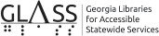

Newsletter by email

Are you interested in receiving this newsletter by email? The HourGLASS is sent by email with links to accessible versions so you can read it how you would like!

Call GLASS at 800-248-6701 to let us know you’d like to be on our email mail- ing list. You can also email us at hour- glass@georgialibraries.org.
Call 800-248-6701 to request this newsletter in alternate formats.
Join our email list at: hourglass@georgialibraries.org

HourGLASS is published quarterly by the Georgia Libraries for Accessible Statewide Services (GLASS), a division of Georgia Public Library Service, a unit of the University System of Georgia.
This publication is made possible by a grant from the U.S. Institute of Museum and Library Services to Georgia Public Library Service under the provisions of the Library Services and Technology Act.

Georgia Libraries
for Accessible Statewide Services

Toll Free: 1-800-248-6701
Fax: 404-657-1459
www.georgialibraries.org/glass

