www.georgialibraries.org/glass Volume 8, Issue 1 - Winter 2020

Holiday cheer, audio described DVD’s are here!
In the interest of community health and safety, many of us are staying at home. GLASS is expanding our services to include a collection of audio descriptive videos that we hope will make your time at home more enjoyable. Audio descriptive videos are movies that have a voice describing actions, characteristics, and dress of the actors, as well as details of the scenery or setting. This descriptive voice speaks during the time when there is no dialogue.
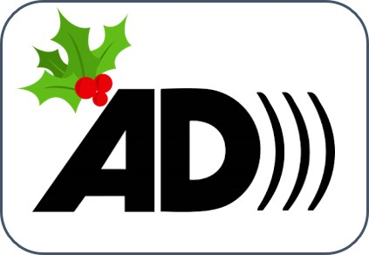
These videos can be enjoyed by
everyone, both sighted and visually
impaired. The videos play on DVD
players and televisions. GLASS
does not loan the equipment to view
the audio described videos. Due to our
limited collection, active registered
GLASS users can borrow one video at
a time for a period of two weeks.
Chronically late returns or damage
to DVDs will result in disqualification from
the audio described DVD program. For a listing of available movies and questions about the audio described movies you may contact GLASS at 404-657-1452 or 1-800- 248-6701.

Holiday Reminders
The winter holiday season is one of the busiest times of the year for talking books and braille
libraries!
Note, GLASS Atlanta will observe the following holiday hours: Halloween and Veterans Day: Regular hours Thanksgiving: Closed Thanksgiving Day and November 25th Christmas: Closed Christmas Eve and Christmas Day
New Year’s: Closed New Year’s Eve and New Year’s Day

Lend your voice! We need you!
The GLASS Library Consumer’s Advisory Council (LCAC) will be holding an election
for officers and members-at-large at the next general meeting on Monday March 1, 2021 from 11am to 1pm. The LCAC is recruiting library users who are interested in serving on the Council.

The purpose of the LCAC is to give advice and make recommendations to GLASS on practices, policies, and goals that will aid in the improvement of library service to the blind and physically disabled. The Council also serves as an advocate for the promotion and further development of library services to all blind and physically disabled. Meetings are held twice a year on the first Monday in March and August.
If you have ideas and suggestions on improving library service to the blind and physically disabled and have a desire to serve on the council, call GLASS at 404-657- 1452 or Rosetta Brown, Chair, at 678-995-8272 for more information.

Leaves: A poem by Elsie N. Brady

How silently they tumble down And come to rest upon the ground To lay a carpet, rich and rare, Beneath the trees without a care,
Content to sleep, their work well done, Colors gleaming in the sun.
At other times, they wildly fly Until they nearly reach the sky. Twisting, turning through the air
Till all the trees stand stark and bare. Exhausted, drop to earth below
To wait, like children, for the snow.

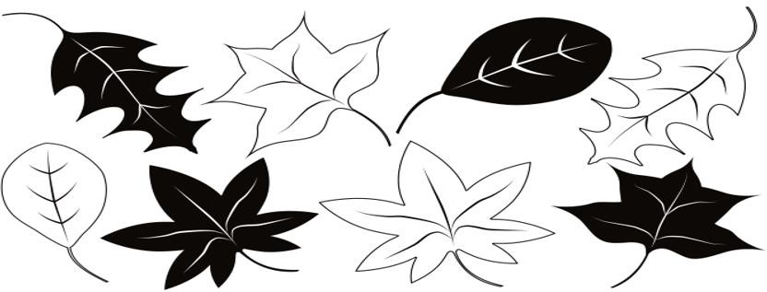

The OPAC is packed with titles

Have you visited your OPAC? An OPAC is an Online Public Access Catalog and you can access yours right from the GLASS website on the Catalog tab. The catalog is the point through which users can download locally produced digital talking books as well as titles from the NLS BARD
catalog. Some users find it much easier to search than is the BARD catalog. If you download with traditional BARD you can link straight to the download from the GLASS OPAC. You can also add titles to your book basket to download later. Visit at https://glass.klas.com/index.jsf

Books about outer space

Note: Talking books begin with DB. Braille titles begin with BR.
Space Race: The Epic Battle between America and the Soviet Union for Dominion of Space by Deborah Cadbury (DB064644) Examines the superpower rivalries that fueled the race to the moon and the engineering masterminds behind it: Sergei Korolev in the Soviet Union and Wernher von Braun, a former Nazi, in the United States.
Discusses the political paranoia of the cold war era and the technological advances it produced. 2006.

Space Chronicles: Facing the Ultimate Frontier by Neil deGrasse Tyson (DBC00149, on Bookshare) America's space program is at a turning point. After decades of global primacy, NASA has ended the space shuttle program. Tyson--one of our foremost thinkers on all things space--illuminates the past, present, and future of space exploration and brilliantly reminds us why NASA matters now as much as ever. 2013.

Space Odyssey: The First Forty Years of Space Exploration by Serge Brunier (DB059478) French journalist chronicles
the landmark achievements of humankind's space ventures from Yuri Gagarin's inaugural flight and Neil Armstrong's first steps on the moon to twenty-first-century Mars probes. Discusses Russian and American missions, technological developments, the International Space Station, challenges posed by deep space exploration, and more. 2000.

Captain Underpants and the invasion of the incredibly naughty cafeteria ladies from outer space by Dav Pilkey (DBC13208, on Bookshare) An alien spaceship has conveniently landed on the roof of Jerome Horwitz Elementary School. At the same time, George and Harold pulled off the prank of their careers by tricking the cafeteria ladies into flooding the school with slimy lime-green foam. Fed up, the cafeteria ladies quit, leaving room for three massive, tentacled space aliens in disguise to assume their positions and slowly change all the children into evil lunchroom zombie nerds. Only the amazing Captain Underpants can save the day now. For grades 2-4. 1999.

Georgia Libraries for Accessible Statewide Services
FREE MATTER FOR THE BLIND AND PHYSICALLY HANDICAPPED
2872 Woodcock Boulevard, Suite 200 Atlanta, GA 30341

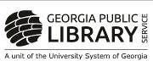
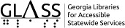

Like Us on Facebook
For announcements about GLASS services, closures for the holidays, and just general interesting news, be sure to like and follow us on Facebook!
You can find our page by searching for georgialibrariesglass.
Leave a comment on the page! We’d love to hear from you.
Call 800-248-6701 to rReeqquueesst t this newsletter in alternate formats. Join our email list at:
hourglass@georgialibraries.org

HourGLASS is published quarterly by the Georgia Libraries for Accessible Statewide Services (GLASS), a division of Georgia Public Library Service, a unit of the University System of Georgia.
This publication is made possible by a grant from the U.S. Institute of Museum and Library Services to Georgia Public Library Service under the provisions of the Library Services and Technology Act.

Georgia Libraries
for Accessible Statewide Services
Toll Free: 1-800-248-6701
Fax: 404-657-1459
www.georgialibraries.org/glass

