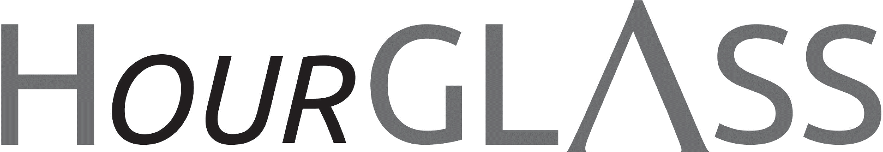

gls.georgialibraries.org
Breaking GLASS to Rebrand

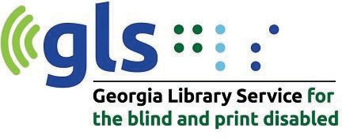
GLASS is now the Georgia Library Service for the Blind and Print Disabled or GLS. We still have the same great services with a new name and look that better reﬂects what we do.

Although GLASS had a great reputation with our patrons and community partners, we felt that we needed a name that more clearly deﬁned our purpose, especially for those who were not familiar with Georgia’s talking book library. We’re thrilled with our new name, Georgia Library Service for the Blind and Print Disabled, and feel that it accomplished our goal. We hope our patrons, partners and friends will agree!

This year marks our 90th anniversary and we are pleased to mark this occasion with a new name and look that speaks to

Volume 9, Issue 2, Fall 2021
who we serve. Also, the new look is more aligned with our governing agency, Geor- gia Public Library Service (GPLS).
The GLS Outreach Team is available to schedule presentations and provide up- dates to your organization by contacting us at glsoutreach@georgialibraries.org. All
inquiries about GLS services and programs can be directed to 1-800-248-6701.
What’s happening with NLS libraries

The National Library Service for the Blind and Print Disabled (NLS) is evolving to meet the modern world. Besides recently updating the wording in their eligibility crite- ria, they are working to eﬀectively meet the needs of a growing population of users.

As NLS seeks to deliver their services to people with print disabilities related to
reading disabilities such as dyslexia, they anticipate reaching a larger and possibly younger audience. With this mind, they are working to make BARD Mobile one of their key means of delivering books.

A newsletter for friends of the Georgia Library Service for the Blind and Print Disabled

NLS libraries: continued

For people who cannot use BARD or BARD Mobile, NLS will continue to lend digital talk- ing book machines. These machines are essential for so many of Georgia Library Service for the Blind and Print Disabled patrons. NLS is also in the process of doing its ﬁnal trials for use of refreshable braille machines that can be lent by NLS network libraries. Because Georgia braille readers are served by the Utah State Library, Utah is providing these ma- chines to our eligible braille readers. This is just another way the NLS is changing with the times. If you are interested in learning more about NLS and their updates to technology, visit https://www.loc.gov/nls/about/
A Poem as We Bid Farewell to Summer

I love to see the summer beaming forth by John Clare
I love to see the summer beaming forth And white wool sack clouds sailing to the north
I love to see the wild ﬂowers come again And mare blobs stain with gold the meadow drain
And water lilies whiten on the ﬂoods Where reed clumps rustle like a wind shook wood
Where from her hiding place the Moor Hen pushes And seeks her ﬂag nest ﬂoating in bull rushes
I like the willow leaning half way o’er The clear deep lake to stand upon its shore
I love the hay grass when the ﬂower head swings To summer winds and insects happy wings That sport about the meadow the bright day And see bright beetles in the clear lake play

GLS move News
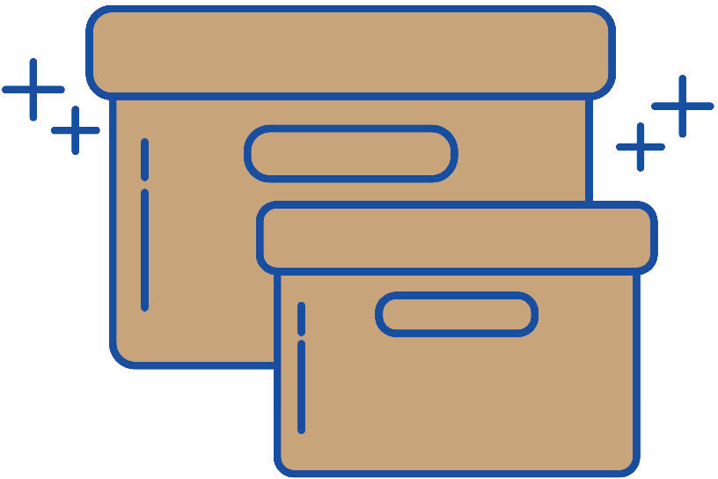From the oﬃce changes, to the walk-in location temporary shift, to the rebranding, GLS has been a ﬂurry of activity for quite some time! Some of the dust is starting to settle and we expect to be full service in our new walk-
in location some time in fall 2021. Our new address is One Margaret Mitchell Square, NW, Atlanta, GA 30303, the central library in the Fulton County Library system. We’re on the ﬁrst ﬂoor for maximum accessibility and we can’t wait to serve you there!
Books About Poetry
Note: Talking books begin with DB. Braille titles begin with BR.

A beautiful day in the neighborhood: the poetry of Mister Rogers (DB 96626), By Fred Rogers, Available in Bookshare

Lyrics to seventy-ﬁve songs from the children’s television program Mister Rogers’ Neighborhood, collected and presented as a treasury of poems. Lyrics explore topics such as feelings, new siblings, everyday life, and imagination. Commercial audiobook. For preschool-grade 2 and older readers. 2019.

Beauty is a verb: the new poetry of disability (DB 74050), By Sheila Black, Available in Bookshare

Anthology shows disability through the lenses of poetry and essays. Features works of early and mid- twentieth-century poets, such as Josephine Miles and Larry Eigner, as well as from participants in the later “disability/crip poetics” movement, including John Lee Clark and Daniel Simpson. Oﬀers critical commentary. 2011.

Black nature: four centuries of African American nature poetry (DB 73042), by Camille T. Dungy

This anthology of verse by ninety-three writers spans the history of black poetry in America, with the earliest pieces by Phillis Wheatley and the latest by Nikki Giovanni and Rita Dove. The 180 selections are presented in themed cycles rather than chronologically. 2009.

American poetry.: volume one The twentieth century, Henry Adams to Dorothy Parker. (DB 87167) By Various authors
Poetry from the turn of the century to the end of World War II--a period of unprecedented creative ferment.
Generous selections are provided from the work of T. S. Eliot, Ezra Pound, Gertrude Stein, Wallace Stevens, Marianne Moore, Edna St. Vincent Millay, and scores of other poets, both major and minor. 2000.

Georgia Library Service for the Blind and Print Disabled
FREE MATTER FOR THE BLIND AND PHYSICALLY HANDICAPPED
2872 Woodcock Boulevard, Suite 200
Atlanta, GA 30341

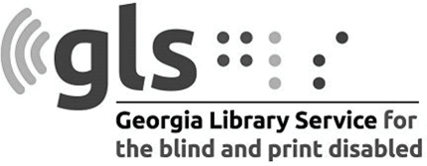

Newsletter by email

Are you interested in receiving this newsletter by email? The HourGLASS is sent by email with links to accessible versions so you can read it how you would like!

Call GLS at 800-248-6701 to let us know you’d like to be on our email mail- ing list. You can also email us at hour- glass@georgialibraries.org.
Call 404-235-7157 to request this newsletter in alternate formats.
Join our email list at: hourglass@georgialibraries.org

HourGLASS is published quarterly by the Georgia Library Service for the Blind and Print Disabled (GLS), a division of Georgia Public Library Service, a unit of the University System of Georgia.
This publication is made possible by a grant from the U.S. Institute of Museum and Library Services to Georgia Public Library Service under the provisions of the Library Services and Technology Act.

Georgia Library Service
for the Blind and Print Disabled
Toll Free: 1-800-248-6701
Fax: 404-657-1459
https://gls.georgialibraries.org/

