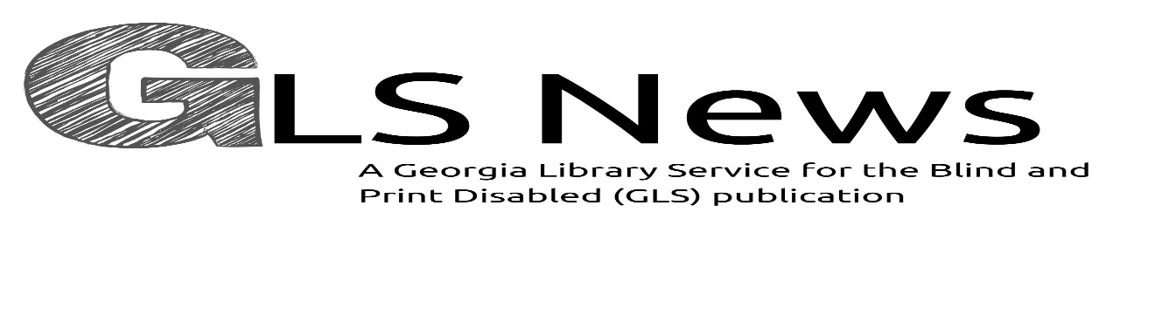

gls.georgialibraries.org
Pat Says, “Farewell to GLS”

I know that many of you have never met me, however, for the past eight years, I have been working behind the scenes as director of GLASS, now called Georgia Library Service for the Blind and Print Disabled (GLS). These years have been ones of tremendous change to a library service for the blind that began in 1931. Over those 90 years the service has evolved from a braille-only book lending service that served only blind adults to an audiobook and braille service that serves people of all ages and includes persons with various conditions that cause them to be print impaired. GLS serves children, serves people who cannot physically hold a book and turn pages and serves people with diagnosed reading disabilities such as dyslexia. Our goal has been to provide our patrons with first-class library service that specializes in meeting the needs of people with vision impairment and other disabilities to make sure that they can read whatever they want to

Volume 9, Issue 3, Winter 2021

read, whenever they want to read it. Our agency’s vision statement says, “Accessible books for every life, every reader, every day.” We value service, accessibility, inclusion, and community. That staff includes our helpful, friendly, and knowledgeable readers advisors as well as the circulation staff who work hard to get books and digital talking book machines into the mail. Our great outreach team has worked hard over the years to publicize our program and to make sure that people across Georgia know about GLS. Our efforts are administratively supported by Georgia Public Library Service, a state agency that works to better public library service across the state. With our staff and our administrative support, I hope that you are getting the library services that you need and deserve. It has been an honor to serve you through the services of GLS. I will miss the opportunity to work for a better future for GLS. Farewell my friends; do take care.

Pat Herndon, GLS Director and Asst. State Library Director retired in October.

A newsletter for friends of the Georgia Library Service for the Blind and Print Disabled

GLS Staff Share Why They Are Thankful

“I am thankful for my friends and family who continue to support me, pushing me to be the best version of myself. I am thankful for all the technology that I have access to, which I get to share with others in the form of education.”
Craig Roberts, Jr. - Distribution Supervisor

“I am thankful that I have been able to work safely and provide a service to our patrons during these uncertain times.” Barnaby Camp, Reader Advisor

“I am thankful that the staff can provide GLS services to our patrons during this Pandemic while staying safe. I am glad when patrons call and say this service is a lifesaver for them. Most of all, I am thankful that I have the privilege to speak to our patrons and learn how much each person enjoys our service.” Vanessa Meadows, GLS Assistant Manager

“I am thankful for our patrons! The heartfelt gratitude I hear each day from our patrons for the work that we do to keep them reading and engaged is very special to me. I feel a tremendous amount of pride knowing I have been able to brighten someone’s day. It fills my cup to overflowing! Thanks go out to all of our valued readers! Please, everyone, stay safe and warm this holiday season.” Daniel Chrismer, Reader Advisor

“I am thankful for Wi-fi and DoorDash. No but seriously, I am thankful for hope. Although the past year has been difficult, hope has kept me engaged and useful to those I care about. Hope also has kept me going as I am sure there is light at the end of this pandemic tunnel. And for that, I am grateful.” Nakisha McNeal, Reader Advisor

How Do I Say Thank you? By Vivian Patel

How do I say Thank You for all the hard work you’ve done?
How do I say Thank You for the care you’ve shown my son?
How do I say Thank You for the long hours you have spent?
For your dedication, selfless giving, and all that you have meant.
Grading papers, planning lessons, reports, projects, and so much more.
In service of creating a better world, you open up doors.
You open minds, you open hearts, You buff until their shine bursts through.
The glow of light in our children’s eyes is there because of you.
How do I show my gratitude, as Thank You, is not enough, by far?
For all you bring into their lives, our precious glittering stars.
There are no words for all you do, daily going beyond and above.

There’s only one that I can see. It is because of LOVE.

Spoken Word Poetry Program
In June, Vanessa Meadows, GLS Assistant manager, hosted a Spoken Word Poetry Program on Zoom. This was not the first poetry program hosted by GLS, but it was the first virtual one. The poetry program was a huge success with eight patrons signed up to present original and published poems during a 90-minute program. This engaging event was attended by 34 attendees including patrons, friends and staff from near and far. All of the presenters were blind except for one presenter who was asked to read a poem on behalf of the poet. The talented readers expressed their love, gratitude and pride through original spoken word, and others read notable works from famous poets like Maya Angelou and Langston Hughes. According to Vanessa, this popular event is a “keeper” and she is thinking about when she will host her next Spoken Word Poetry Program in 2022.
Books About Family and Cooking
Note: Talking books begin with DB. Braille titles begin with BR.

The Vanishing Half (DB 99791), By Brit Bennett, available in Bookshare
Desiree Vignes and her daughter return home to Louisiana in 1968, fourteen years after Desiree and her identical twin sister Stella ran away. The sisters ended up on different paths, and Stella lives her life passing as white. Violence, strong language, and some descriptions of sex. Commercial audiobook. Bestseller. 2020.

Happiness, as Such (DB 98073), By Natalia Ginzburg, available in Bookshare
Michele fled to England to escape the dangers of his radical political ties. Their interconnections, joys, and tribulations are revealed through their letters. Translated from the 1973 Italian edition. 2019.

Food: What the Heck Should I Cook? (DB97791), By Mark Hyman
Companion cookbook to Food: What the Heck Should I Eat? (DB97825). Discusses nutritional philosophy, mindset for choosing what to cook and eat, and focusing on quality over quantity. 2019.

A Table for Friends: The Art of Cooking for Two or Twenty (DB1003107) By Skye McAlpine
Cookbook featuring recipes easily scalable from an intimate gathering to a much larger one and responsive to the seasonal availability of ingredients. Includes advice on preparing for entertaining. 2020.

Georgia Library Service for the Blind and Print Disabled
FREE MATTER FOR THE BLIND AND PHYSICALLY HANDICAPPED
2872 Woodcock Boulevard, Suite 200
Atlanta, GA 30341

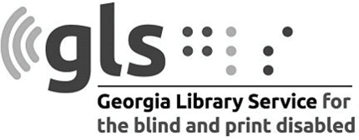

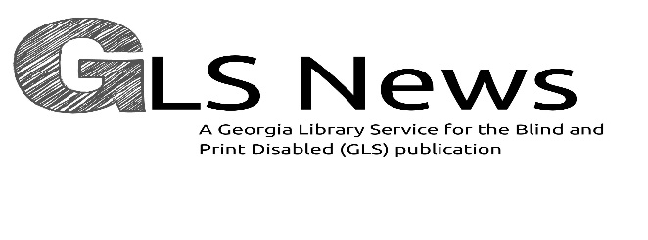
Newsletter by email
Are you interested in receiving this newsletter by email? The GLS News is sent by email with links to accessible versions so you can read it how you would like!

Call GLS at 800-248-6701 to let us know you’d like to be on our email mail- ing list. You can also email us at glsnews@georgialibraries.org.
Call 800-248-6701 to request this newsletter in alternate formats.
Join our email list at: glsnews@georgialibraries.org
GLS News is published quarterly by the Georgia Library Service for the Blind and Print Disabled (GLS), a division of Georgia Public Library Service, a unit of the University System of Georgia.
This publication is made possible by a grant from the U.S. Institute of Museum and Library Services to Georgia Public Library Service under the provisions of the Library Services and Technology Act.

Georgia Library Service
for the Blind and Print Disabled
Toll Free: 1-800-248-6701
Fax: 404-657-1459
https://gls.georgialibraries.org/

