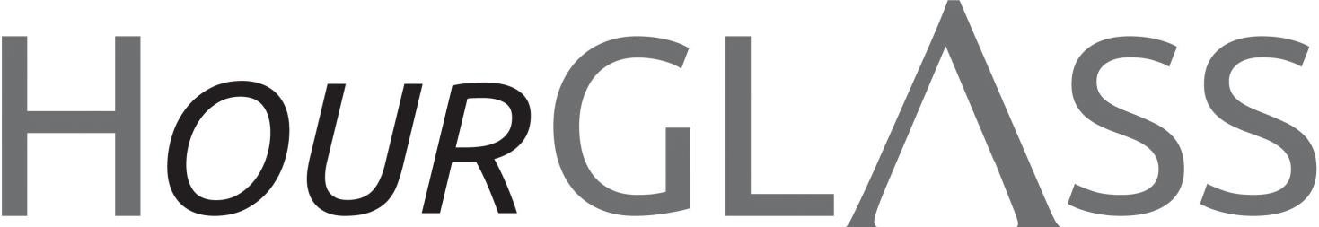
www.georgialibraries.org/glass Volume 8, Issue 1, Spring

2021
Outreach On-Call!
A collection addition!

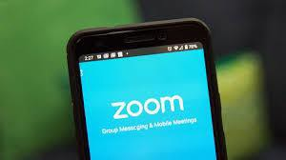
Since August of last year, the GLASS Outreach team has hosted a weekly information session phone call. The purpose of this program is to give a general overview of GLASS, to highlight some features of the service like the Peer Support phone call and give some basic instructional information on using features like BARD Express and BARD Mobile.

Sandy Henry, patron since 2012 and Outreach On-Call participant, has this to say about the program: “I’m so grateful for this program!” She adds that she really loves the “tremendous patience” that is extended to her as a GLASS patron and she “loves the additional access to GLASS staff that the phone call provides and the interaction that
takes place.” Sandy would like to see a discussion on how BARD compares to Audible, so that may be on the horizon!

For more information about the Outreach On- Call phone call including the joining information, visit our website and click the events tab, https://georgialibraries.org/glass/atlanta/. The 1st quarter schedule is listed on pg. 2.
We’re happy to share per Sylvia O’Bear, Middle Georgia’s marketing coordinator,
that in early February, the Middle Georgia Regional Library System (MGRL) will unveil its Junior Braille Collection at Washington Memorial library. The collection came about after MGRL received a $15,000 grant from the Josephine Phelps Fabian Fund, which is a component fund of the Community Foundation. The grant is in partnership with Georgia Academy for the Blind to provide materials for people who have vision impairments.

The monies would increase and support the number of services offered to those with visual impairments in MGRL's service area. MGRL Director Jennifer Lautzenheiser says the collection is essential for children and their families because of MGRL's ongoing partnership with the Georgia Academy for the Blind. These materials will offer them new resources when they return to the branch with their families.

Note that GLASS contracts with the Utah State Library to provide braille materials to our eligible residents. GLASS also facilitates access to embossed or digital braille as well. Call reader advisors at
1-800-248-6701 for additional information.

Accessible resources on COVID-19

Do you or your organization need accessible Word documents, PDFs or braille on pertinent COVID-19 information? The Centers for Inclusive Design and Innovation (CIDI) offers tremendous COVID-19 informational resources in accessible formats. Their goal is to increase access to information about COVID-19, and the project was made possible with funding from the CDC Foundation.
They also offer webinars and training with topics like "Facemasks and People with Disabilities" and "Making Social Media Accessible.” You don’t want to miss the learning opportunity these webinars offer so visit the CIDI site to register soon, https://cidi.gatech.edu/covid.

Here’s a riddle to enjoy!
Only one color, but not one size, Stuck at the bottom, yet easily flies.
Present in sun, but not in rain, Doing no harm, and feeling no pain. What is it? (Answer on page 4)

Outreach On-Call Schedule
Here is the schedule for January through March 2021. Patrons will be emailed
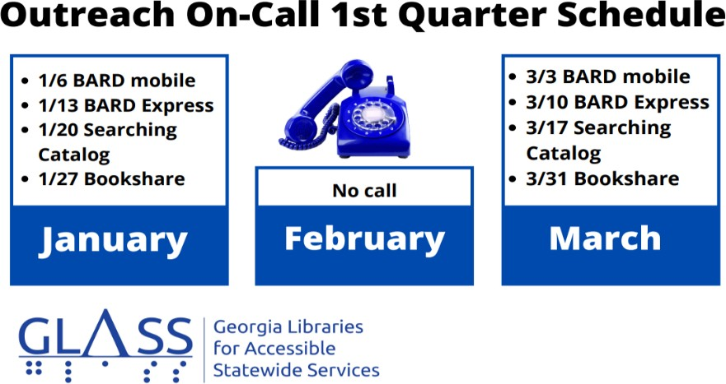if there are updates.
- January: 1/6 BARD Mobile, 1/13 BARD Express, 1/20 Searching Catalog, 1/27 Bookshare
- February: No Call
- March: 3/3 BARD mobile, 3/10 BARD Express,
3/17 Searching Catalog, 3/31 Bookshare

African American biographies in honor of Black History Month!

Note: Talking books begin with DB. Braille titles begin with BR.
Claudette Colvin: twice toward justice by Phillip M. Hoose (DB68732), Available in Bookshare
Uses interviews to provide a firsthand account of fifteen-year-old Claudette Colvin's arrest for refusing to give her bus seat to a white woman in 1955 Alabama. Explains the era's racial segregation policy and the consequences of Claudette's demand for her constitutional rights. Some strong language. For grades 5-8.
Newbery Honor Book. 2009.

The immortal life of Henrietta Lacks by Rebecca Skloot (DB 70661), Available in Bookshare
Science journalist chronicles the life of African American Henrietta Lacks, who in 1951 had cervical tissue removed and grown in culture--without her permission-- producing the first continuously replicating human-cell samples for research.
Discusses subsequent medical breakthroughs, including the polio vaccine and AIDS treatment. Explores bioethical concerns involving tissue ownership.
Bestseller. 2010.

Between the world and me by Ta-Nehisi Coates (DB 82201), Available in Bookshare

In a profound work that pivots from the biggest questions about American history and ideals to the most intimate concerns of a father for his son, Ta-Nehisi Coates offers a powerful new framework for understanding our nation’s history and current crisis.

Life in motion: an unlikely ballerina by Misty Jones Copeland (DB 78843), Available in Bookshare
Ballerina recounts her experiences as the first African American soloist for the American Ballet Theatre in New York City. Explains her status as a latecomer to dancing at the age of thirteen and details her personal struggles with food, racism, and self-doubts. 2014.

Georgia Libraries for Accessible Statewide Services
FREE MATTER FOR THE BLIND AND PHYSICALLY HANDICAPPED
2872 Woodcock Boulevard, Suite 200
Atlanta, GA 30341

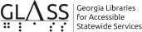

Newsletter

Are you interested in receiving this
newsletter by email? The HourGLASS is sent by email with links to accessible versions so you can read it how you would like!

Call GLASS at 800-248-6701 to let us know you’d like to be on our email mail- ing list. You can also email us at hour- glass@georgialibraries.org.
Call newsletter
Join r
t :
hourglass@georgialibraries.org

HourGLASS is published quarterly by the Georgia Libraries for Accessible Statewide Services (GLASS), a division of Georgia Public Library Service, a unit of the University System of Georgia.
This publication is made possible by a grant from the U.S. Institute of Museum and Library Services to Georgia Public Library Service under the provisions of the Library Services and Technology Act.

Georgia Libraries
for Accessible Statewide Services
Toll Free: 1-800-248-6701
Fax: 404-657-1459
www.georgialibraries.org/glass

Riddle answer: a shadow

