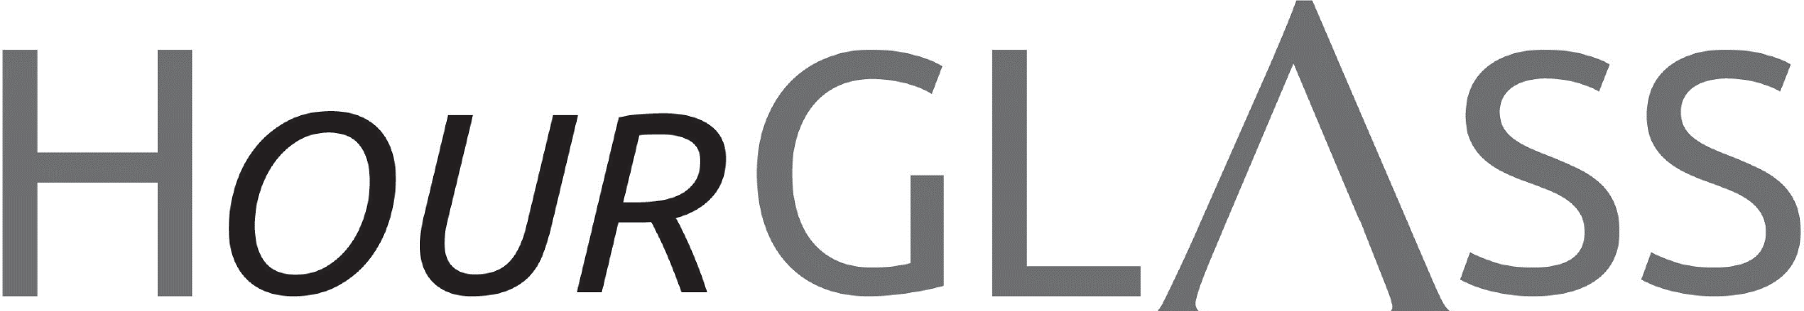

www.georgialibraries.org/glass

Looking Back: GAC Success!
Volume 8, Issue 1, Summer 2021 able to get new ideas, ask questions and earn continuing education credits during this year’s virtual event.

Spotlight: CVI!

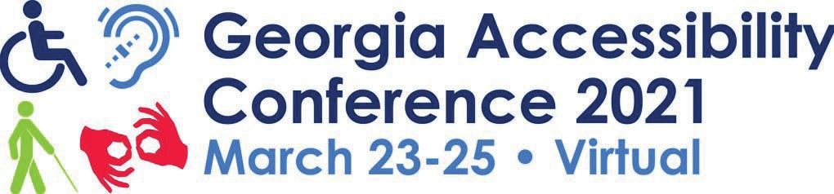GLASS is proud to sponsor and facilitate a biannual conference on accessibility, the Georgia Accessibility Conference (GAC). This event is made available to Georgia librarians and library staﬀ. This year we welcomed presenters from across the
country who shared insights and discussed initiatives that have worked in their pub-
lic libraries. Participants also heard from GLASS staﬀ as they provided GLASS updates and helped Georgia’s librarians be better prepared to promote GLASS in their branches. In addition to the informa- tion sessions, participants enjoyed a fun- ﬁlled session, Cooking With Cecily, hosted by Cecily Nipper. This session featured delicious recipes for ﬂavored popcorn and icebox pie, and host Cecily shared tips for cooking with low vision. The event was very well-received, and participants were
CVI, Center for the Visually Impaired, is a service provider for Georgia’s blind and vi- sually impaired community whose mission is to empower people impacted by vision loss to live with independence and dignity. There, people of all ages who are experi- encing vision loss can receive support and training to facilitate living an enjoyable, independent life.

CVI’s Children and Youth program provides early intervention services, including func- tional vision assessments and specialized classes. Additionally, participants receive support for infants, toddlers, preschoolers, and their families with a goal of helping children who are blind or visually impaired reach their full potential.
School-age children enjoy small group classes in cooking, household skills, braille, orientation and mobility, assistive technology and more.

A newsletter for friends of the Georgia Library for Accessible Statewide Services

Spotlight on CVI: Continued
Students can also gain mentors and participate in social and recreational events on weekends.
CVI optometrists who specialize in low vision, work with patients ages 5 and up in the Florence Maxwell Low Vision Clinic to evaluate their vision and set goals. Clients are also able to meet with an occupational therapist who also specializes in low vision and gain new skills in areas such as cooking and cleaning, orientation and mobility, technology and more. CVI also has an onsite store called the VisAbility Store oﬀering products designed to help people who are visually impaired make the most of their vision and continue to do the things they enjoy.
For information on how you can apply for services or refer someone else who needs CVI’s services, visit cviga.org or give us a call at 404-875-9011.
Spotlight: Project Independence!

Project Independence is a Georgia vision program for adults age 55 or over.
If you, or someone you know, is at least 55 years of age or over and experiencing vision loss or a combined vision and hearing loss, Project Independence can help.

This vision program is administered by the Georgia Vocational Rehabilitation Agency and contracts with service providers located throughout Georgia. The service endeavors to help its clients remain independent and continue enjoying the activities that they like.

Among the program’s oﬀerings are training on safe travel skills, peer support groups,
low vision evaluations and assistive aids/devices to help with daily living e.g., talking watches and various household and kitchen aids.

After receiving services, one client was able to travel indoors and outdoors and was able to use the cane without depending on family and friends to get her to her destinations. With the proper training, her conﬁdence improved. And with the technology and communication skills she learned, she was able to connect with friends and family. Her participation in the peer support groups reassured her that she was not alone and she was not afraid to let her lack of vision slow her down anymore. This is just one of many success stories!

For more information on Project Independence visit: https://gvs.georgia.gov/project- independence or call 844-367-4872 or 404-780-6649.

“Outreach On-Call” Virtual Information Session

Here is the schedule for May 2021: 5/5 Audible vs BARD,
5/12 Inside GLASS,

5/19 Accessing foreign language material,
5/26 BARD Express

There are no calls for June. Patrons will be emailed if there are updates.
Books About Finance
Note: Talking books begin with DB. Braille titles begin with BR.

The ﬁnancial diet: a total beginner’s guide to getting good with money (DB 90396), By Chelsea Fagan, Available in Bookshare
Blogger presents personal ﬁnance advice speciﬁcally targeted to young adults. Discusses the ways money aﬀects various parts of life, including career and relationships, credit, investing, retirement savings, and more. Includes tips on ways to save money, such as learning how to do simple home repairs. Unrated. Commercial audiobook. 2017.

Get a ﬁnancial life: personal ﬁnance in your twenties and thirties (DB 88668), By Beth Kobliner, Available in Bookshare
Journalist presents guide to managing personal ﬁnances for younger adults. Topics include analyzing the state of your ﬁnances, debt, banking, investing, retirement, real estate, insurance, taxes, and military beneﬁts. 2017.

Get Good With Money, By Tiﬀany Aliche, Available in Bookshare
A ten-step plan for ﬁnding peace, safety, and harmony with your money—no matter how big or small your goals and no matter how rocky the market might be—by the inspiring and savvy Budgetnista. 2021

A kid’s guide to earning money: money matters: a kid’s guide to money (DB71149) By Tamara Orr
Oﬀers practical advice for ﬁnding a job appropriate for your interests and skills, from walking dogs to washing cars. Discusses pros (earning extra money) and cons (having less free time), estimating your available work time, understanding youth labor laws, and asking your parents’ permission. For grades 4-7. 2009.

Georgia Libraries for Accessible Statewide Services
FREE MATTER FOR THE BLIND AND PHYSICALLY HANDICAPPED

2872 Woodcock Boulevard, Suite 200
Atlanta, GA 30341

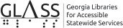

Newsletter by email

Are you interested in receiving this newsletter by email? The HourGLASS is sent by email with links to accessible versions so you can read it how you would like!

Call GLASS at 800-248-6701 to let us know you’d like to be on our email mail- ing list. You can also email us at hour- glass@georgialibraries.org.
Call 404-235-7157 to request this newsletter in alternate formats.
Join our email list at: hourglass@georgialibraries.org

HourGLASS is published quarterly by the Georgia Libraries for Accessible Statewide Services (GLASS), a division of Georgia Public Library Service, a unit of the University System of Georgia.
This publication is made possible by a grant from the U.S. Institute of Museum and Library Services to Georgia Public Library Service under the provisions of the Library Services and Technology Act.

Georgia Libraries
for Accessible Statewide Services

Toll Free: 1-800-248-6701
Fax: 404-657-1459

www.georgialibraries.org/glass

